May Caroline Shortall
Rank: Staff Nurse later promoted to Sister
Unit: 24 GH,
May Caroline Shortall was born at Benalla in October 1870, the daughter of Michael Shortall and Eliza O’Neill.
May was 27 years and 6 months old and working as a Nurse at 14 AAH Macleod when she enlisted on 28th November 1916.
May named her father Michael, a surveyor of Warracknabeal, as her Next of Kin.
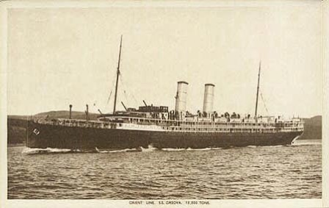
She embarked on HMAT Orsova A67, on 6th December 1916 and arrived in Plymouth on 17th February 1917.
May served in France at 24 General Hospital located at Rouen from 2nd March 1917.
On 18th July 1917 she was posted to the 25 General Hospital also in France and on 23rd November 1917 to the 20th Casualty Clearing Station.
On 26th February 1918 she was granted 3 weeks sick leave to the UK on the authority of a Medical Board convened that day.
On 29th December 1918 May was promoted to Sister and on 4th March 1919 was attached to the 2nd Australian Auxiliary Hospital.
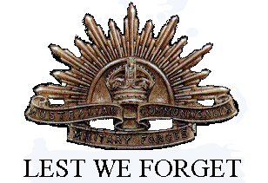
May returned to Australia on the “Port Lincoln” arriving on 14th September 1919 and was discharged on 25th October 1919.
She received the British War Medal and the Victory Medal.
In 1924 May was living at Gaynor Court Parade, Malvern.
Sadly May passed away in Elsternwick in 1935.

