Eliza Smith
Eliza Smith was born in Birmingham England in 1877 the daughter of Mrs Emma Smith of Mosely Road, Birmingham.
She was 39 years and 6 months old and working as a Nurse when she enlisted on 24th July 1917.
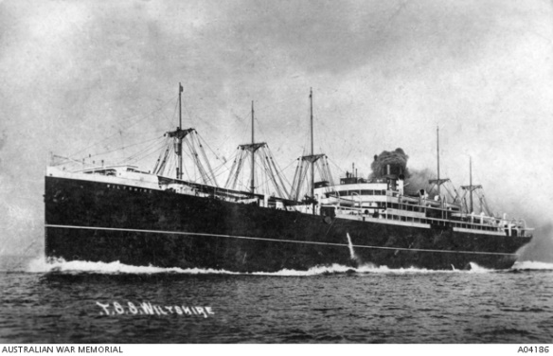
Eliza named her mother as her next of kin.

She embarked on HMAT Wiltshire A18 on 31st August 1917 and served with the 19 Australian General Hospital in Egypt.

Later on leave in England she contracted bronchitis and was returned to Australia.
Eliza managed to re-enlist in 1919 and returned to England where she was discharged on 23rd May 1919 and returned to Birmingham.
Eliza received the British War Medal, the Victory Medal and a Mention in Dispatches in 1917.
