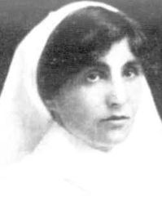
Edith Sommerville Thistlethwaite
Edith Sommerville Thistlethwaite was born in Emerald Hill (South Melbourne) in 1877 the daughter of Edward Thistlethwaite and Isabella Jones. She was 38 years old and working as a Nurse when she enlisted on 10th April 1915 at Ismailia in Egypt.
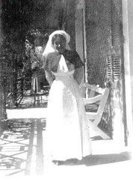
Edith named her mother as her next of kin.

She served with the 1st Australian Stationary Hospital in Alexandria and later at 1st AGH in England and 3 AGH in France during 1916.
In 1917 Edith was attached to the 2nd Australian Auxiliary Hospital in England until February 1918 when she returned to Australia on Hospital Transport Llaudstephen Castle.
Edith she was discharged on 25th November 1918, but continued her service as a Sub Matron at 16 AGH in Macleod.

In 1919 she served at Woodman Point Quarantine Station, Western Australia, where the Spanish Influenza crisis was at its worst, brought about by increasing numbers of infected troops returning from the war.
Edith received the 1914/15 Star, British War Medal and the Victory Medal.
Edith passed away on 10th July 1960 in Heidelberg aged 83.
