Ruby Emily Olive Wilson
Rank: Staff Nurse
Ruby was born at Yan Yean in 1884, the daughter of Thomas Wilson and Catherine King. She was 32 years old and working as a Nurse when she enlisted on 31st October 1916.

Ruby Wilson's address was given as Kerrisdale (on the Goulburn Valley Highway) when she enlisted on 31 October, 1916, with her father as next of kin in 102 Rossmoyne St, Northcote.

Ruby served at the 14 AAH at Mont Park before enlisting.

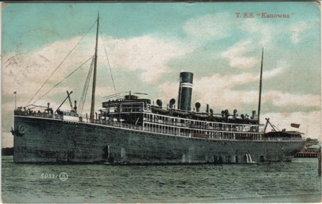
She embarked as a member of staff on HMAHS Kanowna from Sydney on 8 November 1916. She appears to have completed two round trips as a Staff Nurse on the ship before re-embarking for England on 22 December, 1917 on HMAT Ulysses.
HMAHS Kanowna

She served around 12 months on hospital ships and then was assigned to No. 1 AAH at Harefield in England.

Ruby returned to Australia on SS Lancashire in February, 1919.

Sadly, Ruby lost a brother during the war. Norman Claude Wilson served with the 8th Light Horse in Palestine, but after being wounded at Gallipoli, he spent most of the next two years in hospital with a variety of illnesses; diarrhoea, dysentery, conjunctivitis, eczema and blepharitis (severe inflammation of the eyelids). His final admission was to the French Hospital in Damascus on 13 October, 1918 (despite the name, the hospital was briefly under Australian administration when Wilson was admitted). He died five days later, the rather unusual cause given as "malignant malaria".
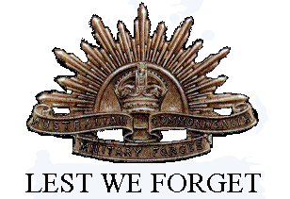
Ruby received the British War Medal and the Victory Medal.
Ruby died in 1963 at Camberwell aged 79.

