Nancy Fyfe---Remembers Rosie Bray
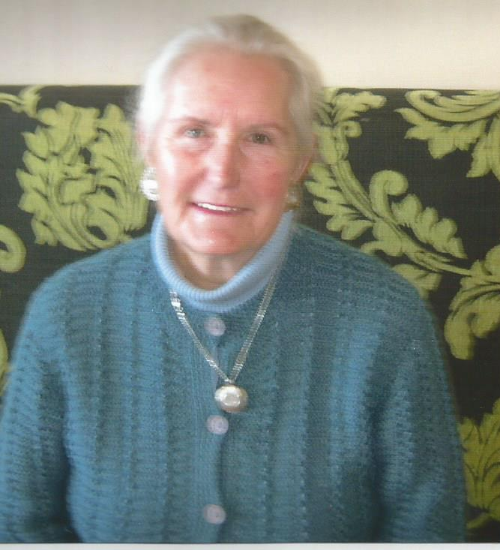
Nancy originally came from Echuca and came to live in Nell Street West Watsonia in 1959. She can remember the primitive conditions, especially unmade streets, and laughs when she remembers the Watsonia Methodist Sunday School using the ‘tin shed’ which is now the Watsonia RSL on Sundays.
When Nancy’s eldest daughter Cheryl was old enough to begin school in 1960, she was to attend Macleod Primary School in Greensborough Road. Having four younger children, Nancy did not fancy walking there twice a day (with the little ones in toe), so she was delighted when Watsonia Primary School opened their doors in February 1960.
Cheryl Fyfe is a foundation student at the school and the four other Fyfe children followed her. One thing that always impressed Nancy was the community spirit. Everyone banded together and helped. People attempted tasks that they never thought was possible. Nancy remembers all the activities of setting up the new school and the pride of the school community as it grew.
Nancy participated in street stall, fetes, and raffles as fundraisers.
And she said that, she enjoyed accompanying the student in their excursions. The one outing that especially stands out, was the trip to the Zoo when everyone had a wonderful time (and no children lost).
Nancy well remembers the excitement in 1968, when the new school Library and Canteen was opened. This was progress indeed.
She also said that the children had an environmental lesson, when they planted trees around the parameter of the school. Each tree had a child’s name on it. This exercise not only provided shade but taught the children the value of trees in the world.
Nancy’s daughter Cheryl’s three children have followed suit and attended Watsonia Primary School, which makes the school very dear to the Fyfe family. They still call it ‘our school’.

Nancy Fyfe is also well known in the Diamond Valley area for her fundraising for Breast Cancer Australia. This involvement came about when Nancy’s son-in-law was diagnosed with breast cancer 30 years ago and she decided there and then to ‘do something about it’ and raise funds for cancer research. Nancy began in a modest way and the fundraising just ‘grew like Topsy’ and last count of Nancy’s efforts is $50.000. The community honoured Nancy with a Commonwealth Senior Citizen’s Award and a gold medal for the year 2000.
Nancy said that it was like winning an Olympic Gold Medal.
Well done Nancy Fyfe a true Watsonia person.

