Denise Scott ... aka Scotty
by Anne Paul

As reported in our previous newsletter Denise Scott was MC and great entertainment at the 2017 Banyule Volunteers Awards.
Across the evening Denise provided some hilarious reflections on her childhood, living and growing up in Greensborough. She was by far the best MC I have ever seen - genuine, courteous, at times irreverent and ever so funny.
Many in the audience had tears of laughter welling up while others were drawing in their breaths as they anticipated her next line. Her references were local and her lines spot-on and because she was talking about places we all knew - Adeline Street, Deloraine Nursing Home, Greensborough swimming pool, Our Lady’s College - well they must have all been true.
This was an opportunity too good to miss for yours truly and in consultation with a by then hysterical President, Denise was duly approached for a Q & A, emails were exchanged and hey presto.... we are honoured to be able to share a little of her Greensborough story... as well as encouraging readers to go out of their way to see her perform.
A little background...
Denise has recently returned from performing at the Soho Theatre in London, with Judith Lucy in the acclaimed show Disappointments, winner of the People’s Choice Award at the 2017 Melbourne International Comedy Festival. They are currently touring with the show and at the time of writing were performing to sell out audiences in Queensland.

Denise’s web biography tells us she was born 24 April 1955 in Australia, is a television and radio presenter, comedian and actor. She met her partner John, whilst in a clowning troupe and has two children. She is also an author, writing “All That Happened at Number 26”, a memoir about moving into a house with her husband, his circus equipment, no savings and a newborn baby, which she later turned into the successful stage show, “Number 26”.
A recent interview by Kerrie O’Brien in the SMH says that as a teenager, Denise dreamt of being a serious actor but it never seemed like a viable option. She was best-known for her comedy, starting in the early 1980’s at La Mama in Carlton, doing stand-up in venues such as Last Laugh in Collingwood and performing at various comedy festivals. She was 56 before she got a dramatic role, reflecting “Good things come to those who wait – I'm only nearly 62, so who knows?" (Denise has recently appeared in Winners and Losers and House Husbands.)
http://www.smh.com.au/entertainment/denise-scott-on-the-c-word-the-liedown-that-lasted-a-year-and-disappointments-20170321-gv2tvm.html
In pondering the best way to frame an email interview I opted for a best memories, friends and places approach ... and from this Denise has provided some lovely recollections, which will be familiar to many, so I hope you all enjoy reading her story.
Back to the 1950’s...
Denise lived at 19 Adeline Street Greensborough, with her mum Margaret, dad Russell and her sister Julie.
“Adeline St in the late fifties was a dirt road. There were no fences between the new, humble, identical war service homes. Housewives dropped into one another’s kitchens for a daily ‘cuppa’. Backdoors were NEVER locked.
Kids from the age of two roamed from one backyard to the other playing until the sun went down when we’d be called inside for ‘tea’. We ate at the table every night -delicious stews followed by custard and tinned fruit. Dad drank a beer. On special occasions Mum had a Pimms.
We were one of the first families in the street to get a TV to watch the ’56 Olympic Games, held in Melbourne. It was placed on our front porch and of an evening all the neighbours gathered in our front yard to watch!”
School Days...
Denise attended St Mary’s Primary School Greensborough, then Our Lady of Mercy College Heidelberg before heading off to Melbourne State College.
“In the early days of St Mary’s, before the church was built, the dividing wall between two class rooms would be opened up, desks moved out, chairs moved in ,and that’s where Mass was held on Sunday Mornings.
I recall in Grade 5 Miss Saddler and Miss Tunnecliffe arriving at school wearing groovy, opaque, 60’s patterned tights , short skirts and teased beehive hairdo’s. – oh how I gazed upon them in awe and wonder.
Every time there was a parishioner’s funeral the entire school would line up, heads solemnly bowed, and give the hearse a guard of honour.
A more painful memory is the end of term, school reports showing not only your marks for each subject, but also showing your place in class – meaning that if there were fifty students in a classroom (and back in the day, there often were) you were ranked in position from 1 to 50 according to your marks!
This was a fairly humbling, some might say soul destroying practice that has thankfully been forgotten.
The summers seemed long and hot. I recall one hot day in particular when I looked out the classroom window and the sky was a swirl of orange smoke. Fires were nearby. We were sent home. My Mum, who did night shift at Deloraine Nursing Home (which is still in Adeline St), was having an afternoon nap. When I told her about the fires she said: “Oh wouldn’t you know it! I just spent two hours mopping and scrubbing the front porch. Now the whole place is going to burn down. What a waste of time that was.” Needless to say we, and our home, survived.
I also remember our, out of control, Labrador dog Prince who used to follow me to school most days and run in and out of classrooms jumping up and enthusiastically licking kids faces. He also used to follow us to Mass on a Sunday and jump all over us inside the Church. Mum’s advice was: “Just pretend you don’t know him.”
Growing Up, Friends and Favourite Places...
Denise recalls her favourite spots and activities and neatly captures the types of things we all got up to back then.
“My best friend was Deborah Hogan. She lived at number 9 Adeline St. Her mum Glad was always baking lovely treats including caramel toffees individually wrapped in wax lunch paper.
One of our favourite past times was to explore the new building sites in the new Watsonia housing estate, climbing over all the new house frames , and crawling in and out of the deep clay trenches before the pipes were installed. We had another friend, also Deborah, and we spent a lot of time hanging out together, sitting high up on a branch in the: “Three Discovery Tree”. It was a tall pine tree we ‘discovered’ and consequently named, in the Greensborough Footy Ground.
I loved the cutting that cleaved Grimshaw St in two . There were tiny little steps, or rather grooves, that had been worn into the rocks that, as kids, we’d have to carefully descend , cross the road, then climb up the other side to get to school.
I loved the Greensborough Swimming Pool. I remember when it opened - bands were playing, schools were marching, speeches were made. It was a major event. I was there every day it was open, rain, hail or shine. It’s where I learnt to swim. And when I hit adolescence it’s where I learnt about boys.
I adored the fish and chip shop in Grimshaw St. Sixpence/five cents worth of chips and sixpence/five cents worth of potato cakes! I’m salivating now, at the very thought.
My absolute favourite place though, was the Greensborough Picture Theatre that was in Main St. Kids would flock there for a Saturday matinee, not a parent in sight. The poor theatre manager would at some point inevitably have to halt the screening and walk down the aisle, his bald head appearing in silhouette, on the now empty screen , and he would yell that the film would only recommence when everyone stopped running around, stopped throwing things and stopped talking. Fun times!”
Leaving Home and a Journey into Comedy...
Denise left home when she was eighteen and moved into a share house in Collingwood.
“I’d always loved the idea of being on stage since I was a kid. In reality though my ‘acting’ career never quite took off so I fulfilled my need for stage action by focussing on stand up comedy.”
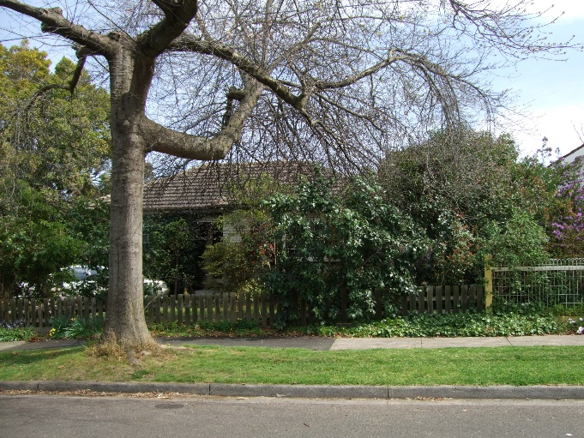

Denise finishes by saying she has been a regular visitor to Greensborough since then.
“My Mum stayed in our Adeline St home until she went into care when she was in her early eighties. So I continued to visit Greensborough throughout my whole life. And these days I haven’t strayed far –I live in Thornbury.”

We appreciate Denise’s time and her lovely reminiscences. I know I couldn’t faithfully repeat her hilarious award night stories – of the nurses’ tea room at Deloraine and her first acting role at Our Lady’s – but reckon its worth exploring her early days a little more.

PS – It was an honour to be the joint winner of the 2017 Banyule Volunteers Awards. We thank Banyule Council for their consideration and donation of which formed part of the award. These funds will be allocated toward the cost of printing our second book.

