Accompanies Item 4726

Medhurst Winery and its links to Greensborough.

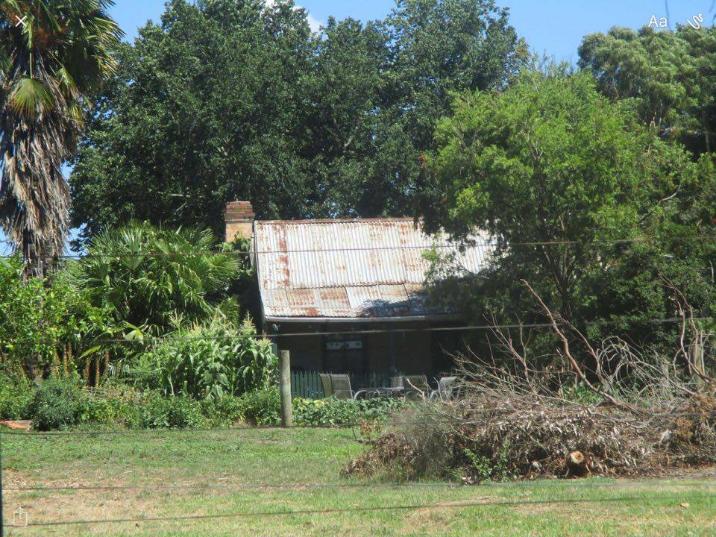
We think this is the old Medhurst home in Medhurst Road Gruyere. The winery is on part of the land which was their farm. There are lots of pear and apple trees around it. They went to live there in 1855 and moved to Greensborough in 1898. In David’s (David Medhurst) history, it states when they went to live there, there wasn’t a Sunday school. So they gathered all the kids in the area and taught them in their kitchen; then the adults started to come also so David built a small church in the corner of one of his paddocks. The old home looks rather large. The owners named the winery Medhurst because it was on Medhurst Road.

