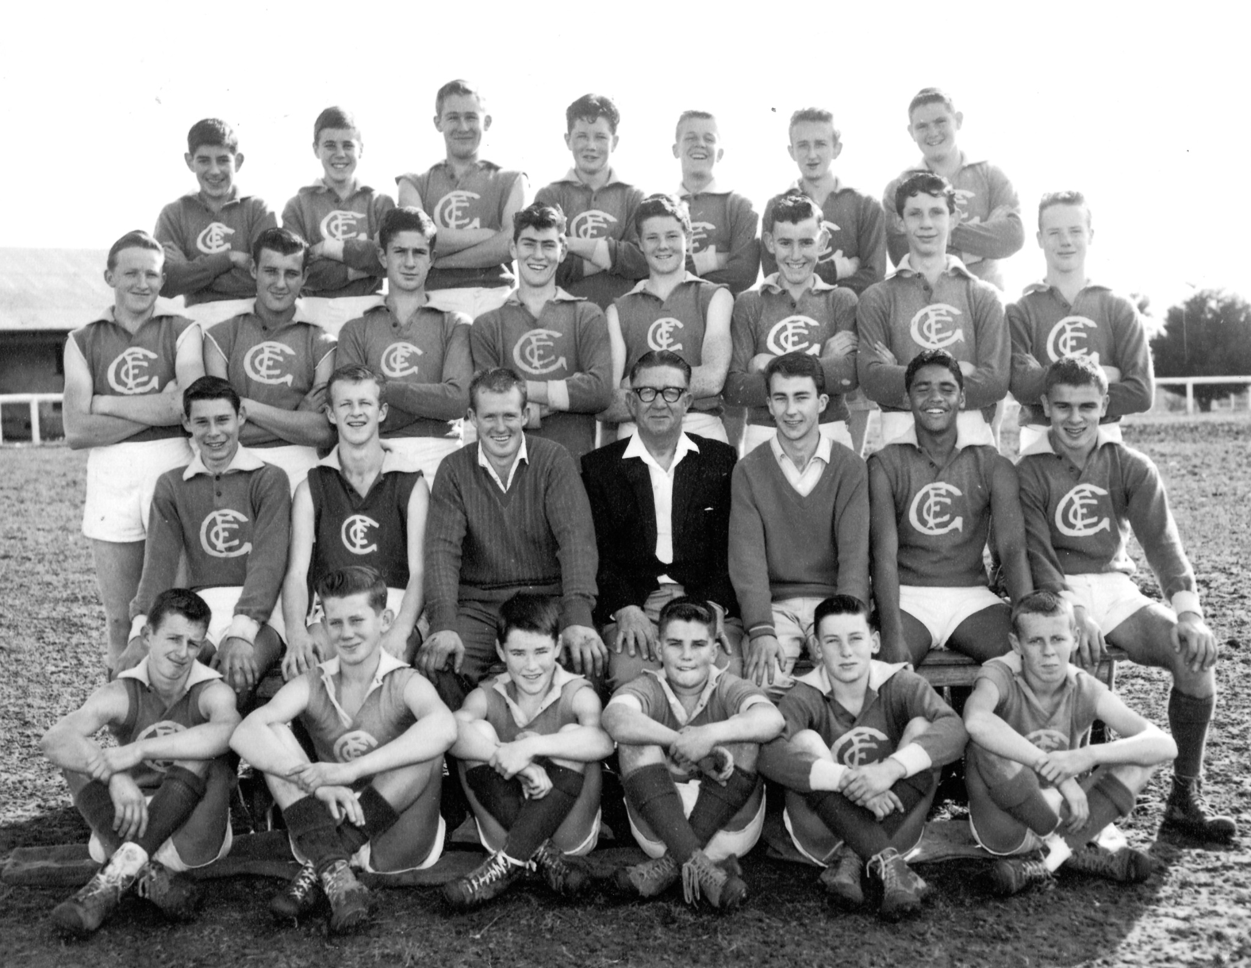

Back Row: R. James, R. Burrows, G. Smith, A. Cook, B. Browning, W. Bolton, D. Gray
Second Back Row: G. Lester, B. Kofoed, G. Coventry, D. Nicholls, I. Adamson, E. Potter, J. Schultze, L. Adamson
Seated: S. Mills, Ray Hall, R. Thomas (Coach), R. Ward (President), T. Dalziel, L. Muir, D. Johnson
Front Row: Bob Hall, J. Partington, P. Spencer, J. Harrison, P. L’Huillier, Geoff Hall

