ANDREW YANDELL RESERVE
With Greensborough Historical Society
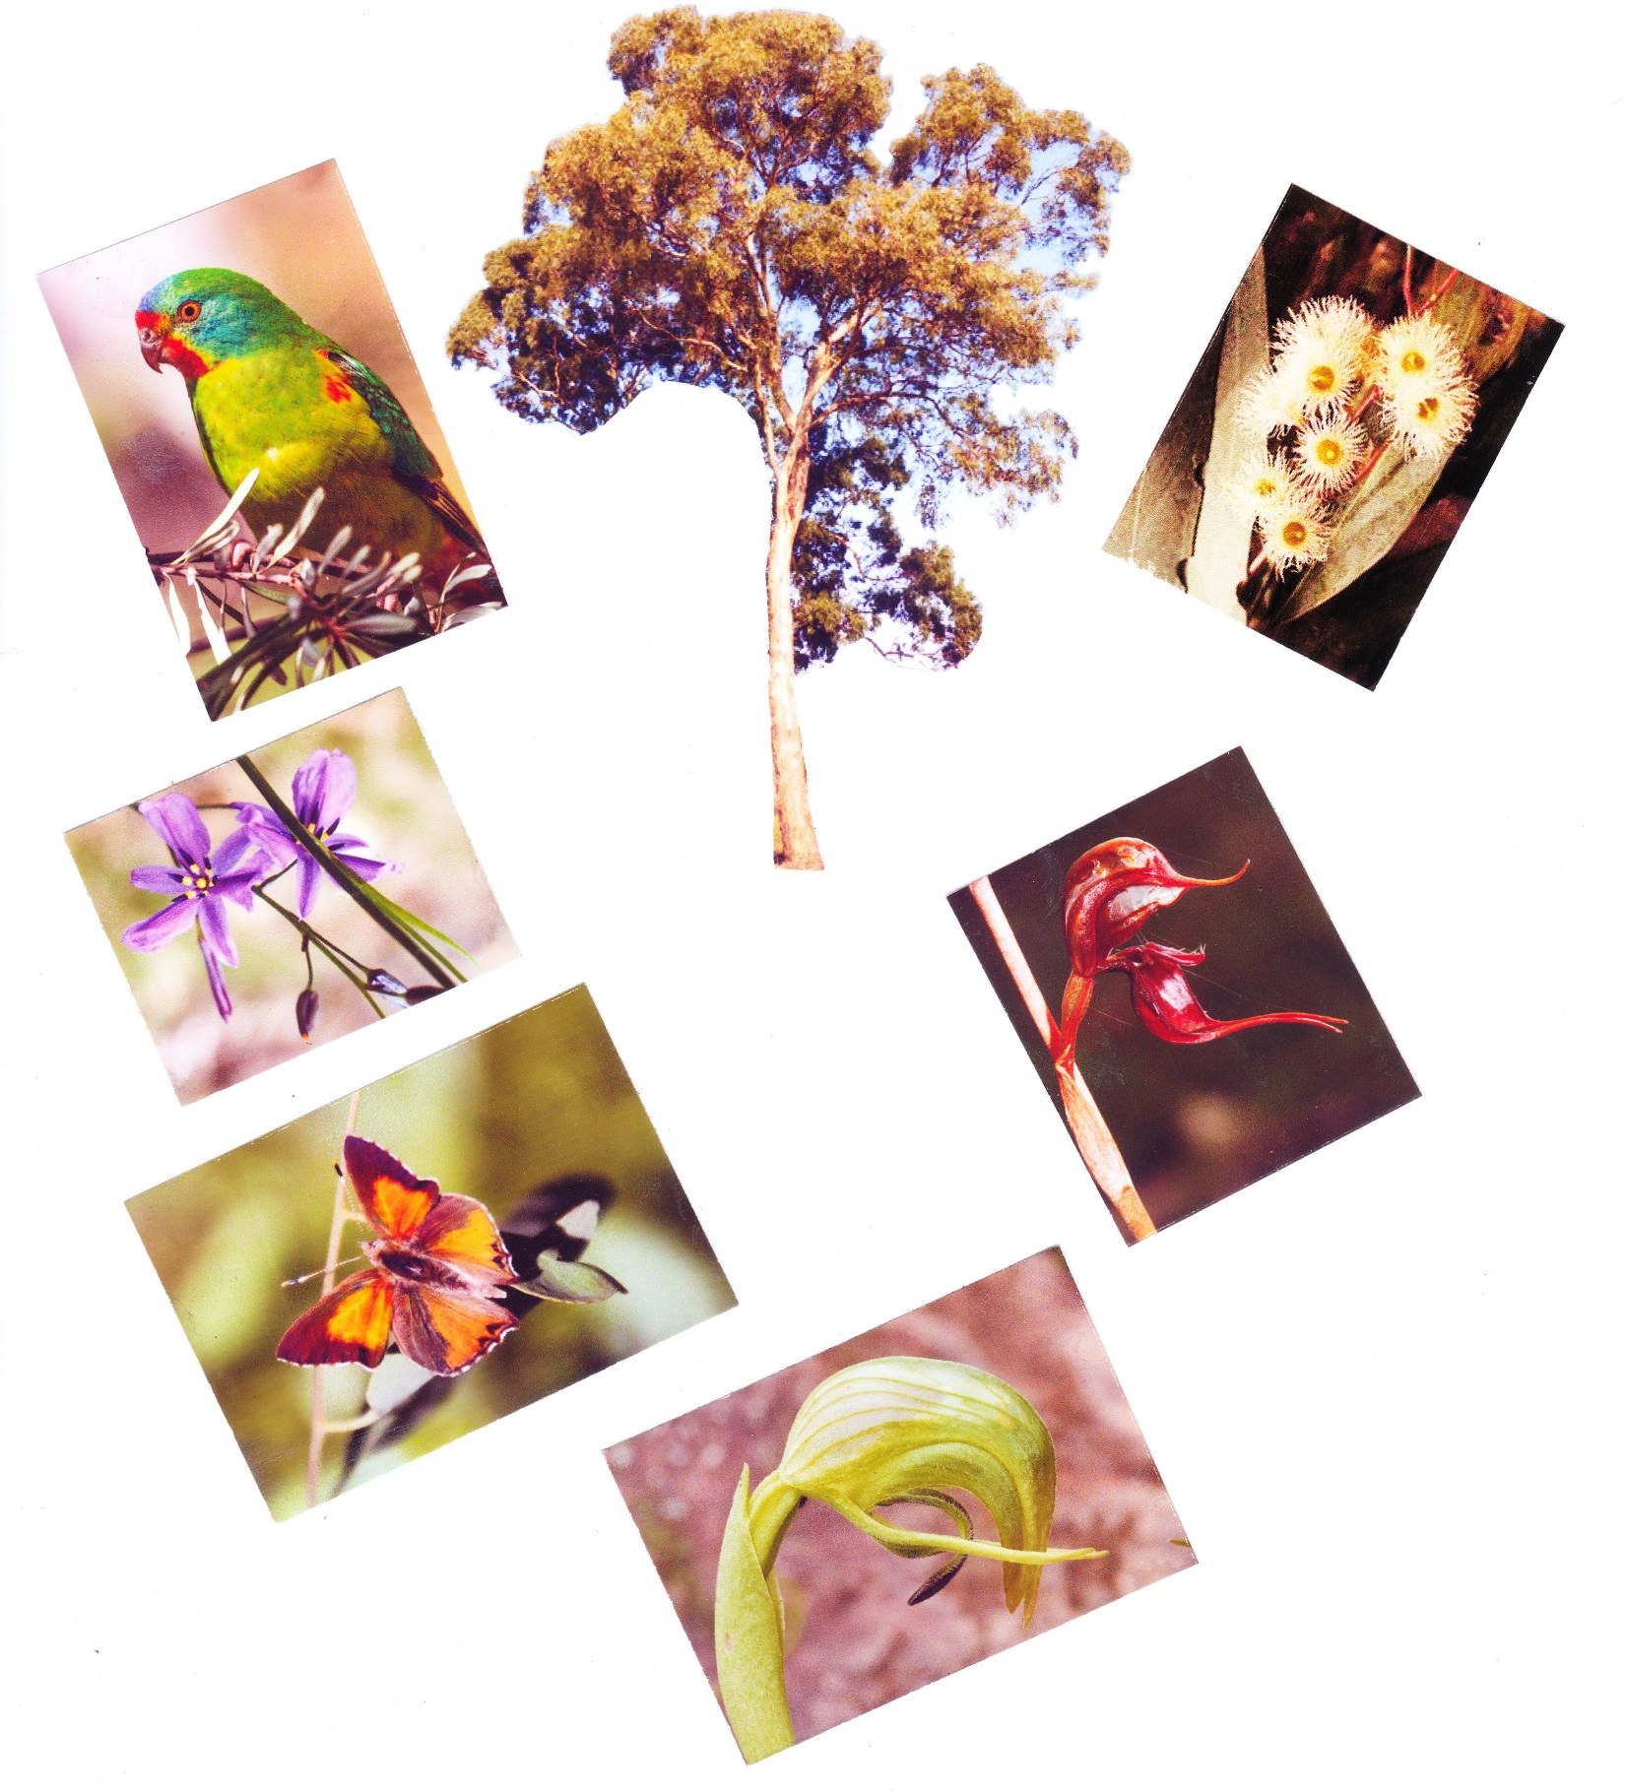

This was the land of the Wurundjeri people for thousands of years until European settlement however once the NSW Government released land in the Port Phillip region it was swiftly taken up by speculators like John Alison who sold his acquisition to Henry Mason who then subdivided it into three parts selling this part to the Mayger Family for £200 each making a handsome profit along the way.

In 1878 Charles Partington and Family became the owners of the 65 Hectare (160 Acres) property stretching from the Plenty River to what became the north/south section of St Helena Road primarily farming the land between the river and Diamond Creek Road.

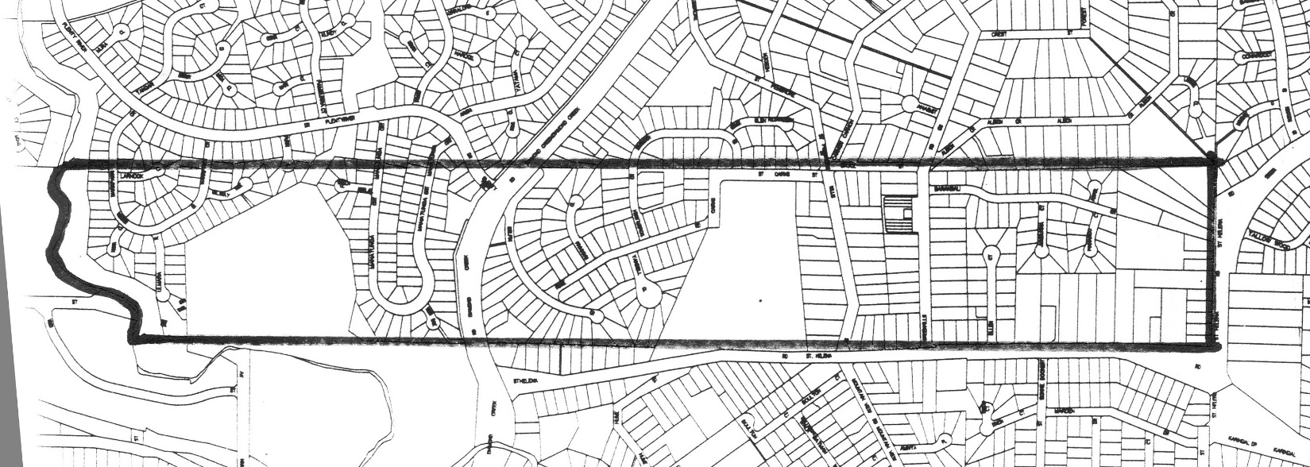

At one stage there was a proposal for a residential subdivisional for the area now Yandell Reserve, fortunately
the local Progress Association lobbied Heidelberg Council to acquire the land as a nature reserve which it agreed to using funds obtained when it sold off its gas department.

As President of the Association Andrew Yandell was instrumental in the push for creating the reserve and it was named after him in recognition.

The significance of the reserve should not be under estimated as there are very few remnant natural bush settings in the Metropolitan area left each containing vulnerable plants, insects, birds and marsupials that are threatened with extinction without environmental awareness and conservation practises by residents and local authorities.

The restricted distribution of Yellow Gum (Eucalyptus Leucoxylon ssp cornata) in Melbourne limits the habitat value for birds and other wild life particularly the Swift Parrot which migrates each year from its native Tasmania seeking food supply in the form of nectar from the flowering eucalypt.
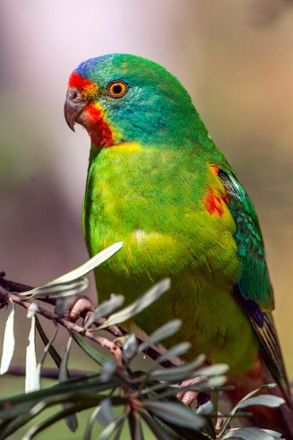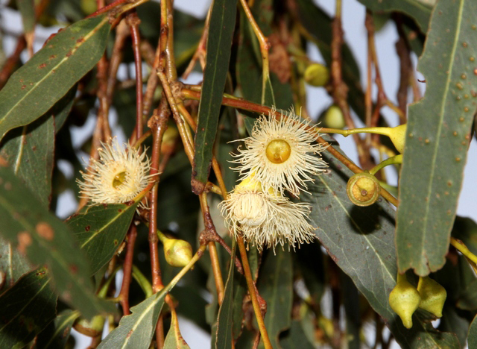
Though the Greenhills Estate still has a number of well establish examples of the tree, the Swift Parrot has not been sighted in the area for some years until recently but its future looks bleak especially as the parrots are threatened by sugar gliders in their own State after migrating to the east coast from Bruny Island.

Yandell Reserve is one of very few places with a colony of what is referred to as the Eltham Copper Butterfly having been discovered there in 1938 and though thought to have become extinct by 1950s colonies were rediscovered in 1987 when local residents and naturalists called for the protection of the species.

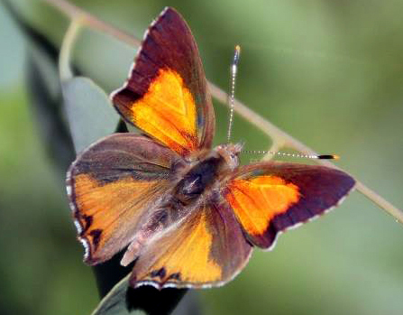

The butterfly has a most interesting life cycle with a fascinating relationship with an ant species and the plant Sweet Bursaria that they both share. The butterfly eggs are laid on the plant at the base of which the ants reside, upon hatching the caterpillars are tended by the ants which accompany the caterpillar into the ant’s nest during the day or bad weather. (Pat Vaughan 1988)

Both species gain from this relationship, the caterpillar shelter and protection while it is believed the ants harvest sugar and amino acids that are secreted from the caterpillar. The butterfly feeds on Sweet Bursaria.

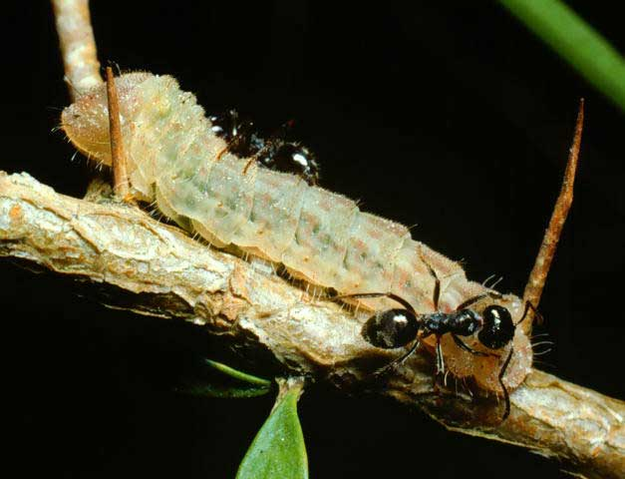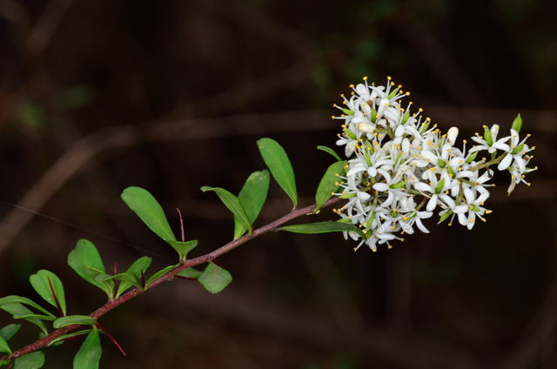
The Eltham Butterfly colony is located at the northern part of the reserve that has been fenced off to protect it from human interference however a colony has been found in another part of the reserve and an additional area has been cleared for revegetation with Sweet Bursaria to increase the population of the butterfly.

On several evenings around October time a larva (caterpillar) count is undertaken by residents and Council staff to determine the butterfly population and it appears to be on the increase.

A look at an 1945 aerial photograph of Yandell Reserve shows it to be far more open than in the 1970s when it had become over grown due to lack of suitable management and introduction of exotic plants by an increased resident population.

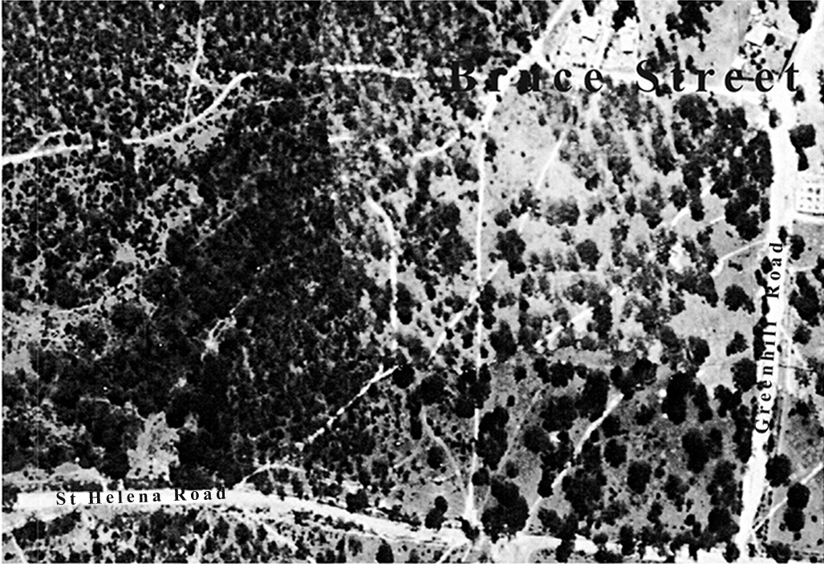

In 1974 the Greenhills Estate supported 45 species of orchids but by 1988 it was down to 20 and declining, the main problem being human interference and considerable invasion of exotic plants and over population of some plants that were retarding the continued growth of the orchid population.

The need for better management of the reserve has been recognised by residents and local Councils over the past 40 years and in recent times Banyule City Council and Friends of Andrew Yandell Reserve have worked together to reduce the profusion of exotic plants such as Cape Broom and thinned out the overgrowth where possible to encourage rejuvenation of lower growing plants.

In recent years there has been an increase in orchid population many of which haven’t been sighted for years including the Spider Orchid and this is the result of cooperation of Council’s Bush Crew and working bees organised by the Friends group and they are to be congratulated on the efforts.

I hope you have enjoyed our walk today.

References include Land for Wildlife Note 21 January 1993
Campbell Beardsell Biological, Land & Planning Assessment Study.

