THE SHOP at 19 Greenhill Road, Greensborough.
Information in this article was supplied in September, 2017, by Mrs Margaret O’Connor, resident at 17 Greenhill Road, Greensborough.
By Dawn Bennetts (nee Petts).

Mr and Mrs Don and Winifred Dobell from Preston, began building the shop in the late 1950’s, and it operated for many years as a general store and grocery shop. The building was extended twice over the years to also include a dwelling in the rear section. The opening of the shop was of major importance to the local people of Greenhills, to save the trip to Greensborough for supplies – as not all people had access to a car in those days.
The first Christmas that the shop was open, there was a huge raffle drawn and local children enjoyed ice creams and a get together with parents.

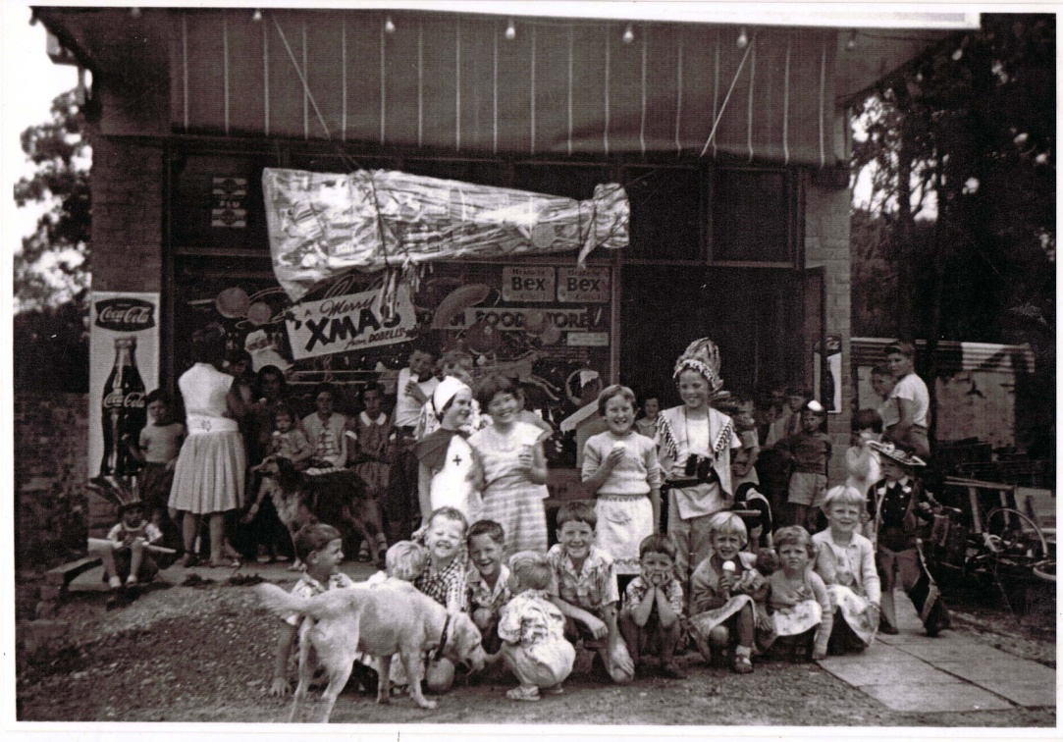
Children at Dobell’s Christmas Party.

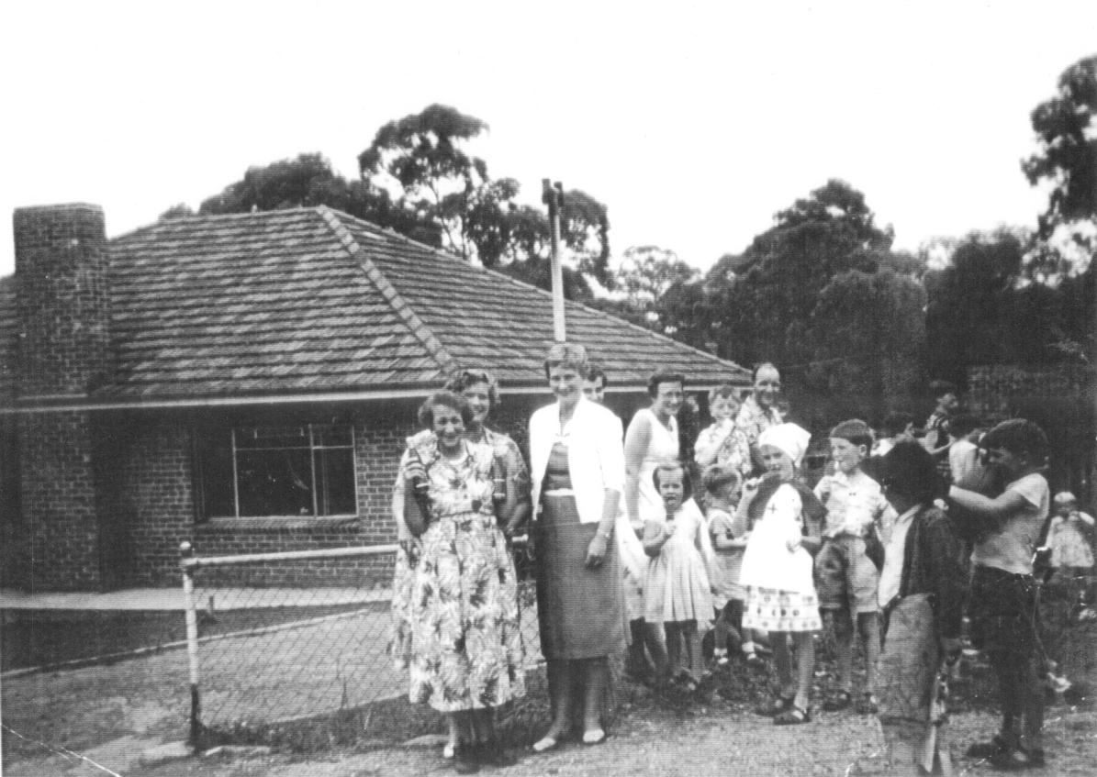
Parents and children at Dobell’s Christmas Party.

The names of some of those in the photos have been provided by Mrs Margaret O’Connor of 17 Greenhill Road. If anyone else is able to provide names of others in the photos, the Greensborough Historical Society would be most grateful.
Over the years the shop has been used for various businesses such as a butcher, grocers, a hairdresser and plumbing supplies. There are still visible signs of the windows that were installed in the side wall and later ‘bricked in’ after the hairdresser ceased operation.
Side of shop showing bricked in windows
In more recent years the shop once again opened under the original name of Dobell’s and operated as a cafe / restaurant until around mid 2014.
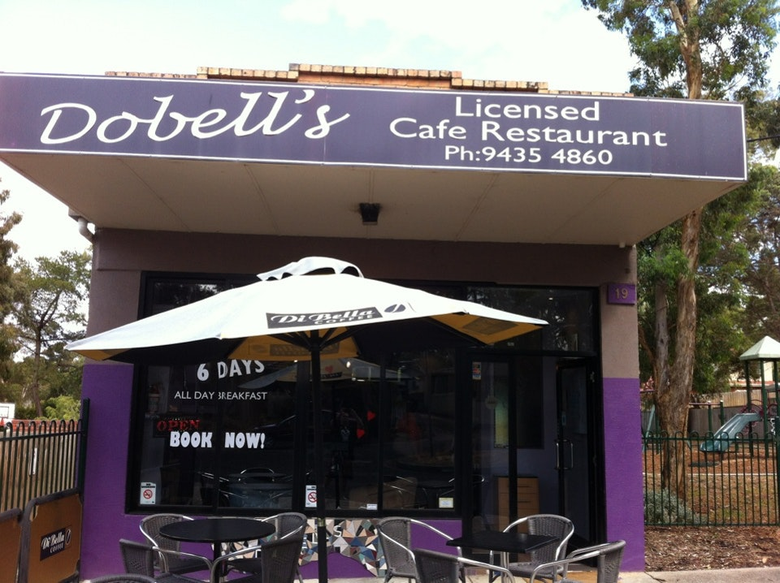
Dobell’s Cafe Restaurant

The business once again changed hands in 2014 and became the Clay Oven Cafe / Restaurant, which is still operating today (2017).
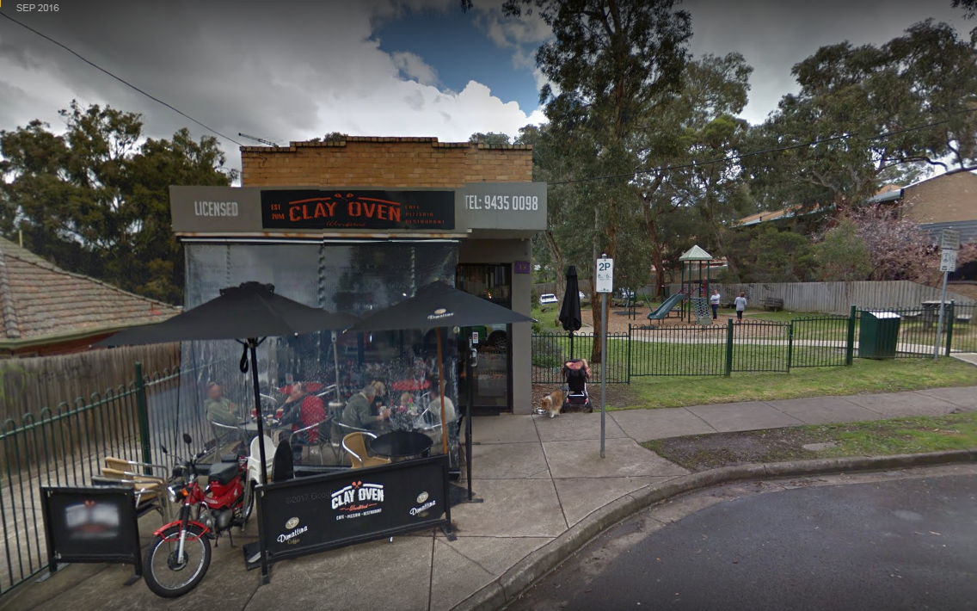
Clay Oven Cafe /Restaurant

