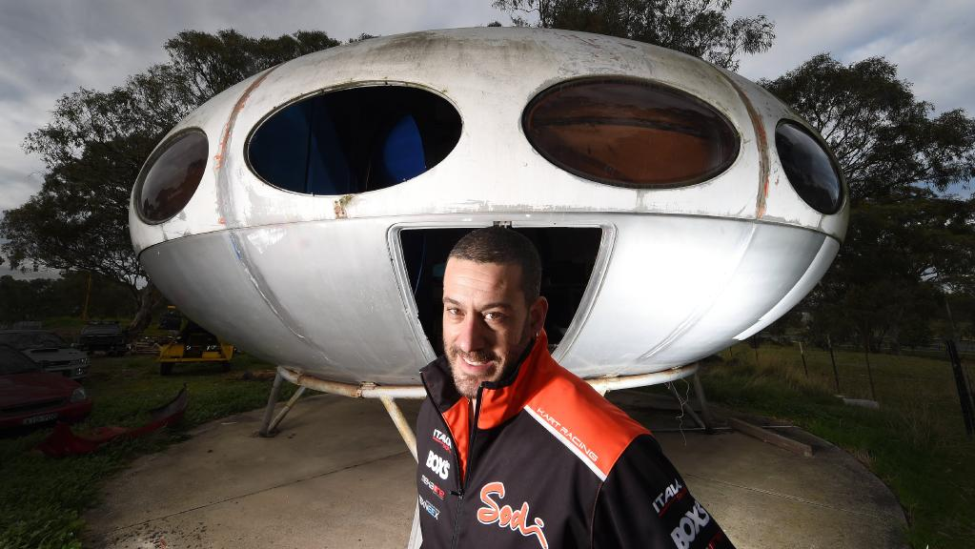

Original Futuro house in South Morang could become tourist icon in more prominent location
Paul Shapiro, Whittlesea Leader
July 2, 2017 12:00am

THERE may be a spike in UFO sightings in the City of Whittlesea in the near future.
What people might be seeing is a unique UFO-shaped house which could become the northern suburbs’ next major tourist attraction.
The Futuro House, a dwelling that would not look out of place in an episode of The Jetsons, has been at the South Morang go kart track for more than 25 years.
However, Whittlesea Council will work with the owners of the spaceship-like fibreglass structure, Canopi Homes, to ensure the protection, restoration and appropriate relocation of the Futuro “to a place with a public presence”.
Planning and major projects director Steve O’Brien said the council would work with the owner to identify potential suitable sites.
Although the house is not heritage listed, a heritage report prepared in 2015 by consultants Built Heritage Pty Ltd considered the building to be of “state significance”.
“The site is not currently heritage listed and there no current proposals to heritage list the property, but it may be considered as part of future heritage reviews,” Mr O’Brien said.
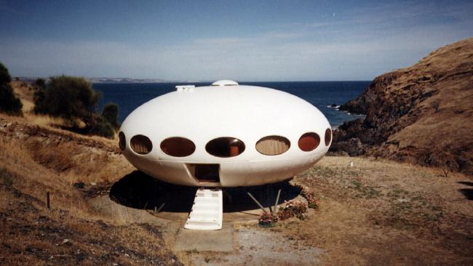

(Another Futuro House is located at Deep Creek in South Australia.)

Mr O’Brien said the council could use the Futuro as a potential tourist attraction.
“The highly distinctive form of the building provides a number of opportunities, however there is no current view as to its future use,” Mr O’Brien said.
The Futuro is currently being used as a storage building by the TUKE Go-Kart Track on McDonalds Rd.
TUKE operator Tina Angelopoulos said it would be sad if the Futuro was moved.
“We’ll miss the UFO, but it’s a tourist attraction and deserves to be restored and put somewhere the public can enjoy it,” she said.
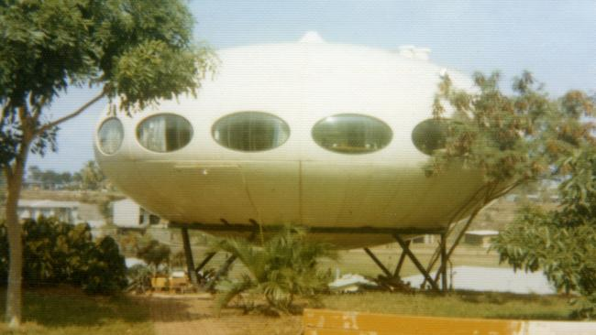
(Peter Dermoudy owned a Futuro House in Darwin but it was torn apart by Cyclone Tracy in 1974. Picture: Norma Burns Collection, Northern Territory Library)

Stockdale and Leggo Bundoora managing partner Paul Boffa has been collecting rent at the track since 1988.
He said his boss Duncan McIntyre bought the Futuro in 1989 and moved it from its original location in Greensborough.
“Duncan bought it from a real estate agent who used the Futuro as a temporary booth for sales of land at a new housing estate called Apollo Parkways,” Mr Boffa said.
“Rumour has it some bloke brought three of them over from Denmark to use as an underwater getaway in Caribbean Gardens, but that never happened.”
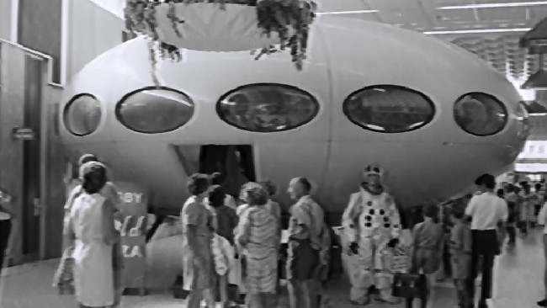
(A Futuro House at an exhibition in the 1970s.)

Mr Boffa confirmed the South Morang Futuro was an original worth $80,000 to $120,000.
The Futuro House was conceived in Finland by Matti Suuronen in 1968 as a “portable” ski chalet.
Fewer than 100 were built during the late 1960s and early 1970s.
There are believed to be five Futuro houses, some real and some replicas, remaining in Australia.

