Interview with Val Mallett – (by Dawn Bennetts and Merilyn Mullavey)

On the 18th November, 2016, Merilyn Mullavey (nee Lewis) and I (Dawn Bennetts – nee Petts), had the opportunity of conducting an interview with Val Mallet at her residence in Leith Park, St Helena.

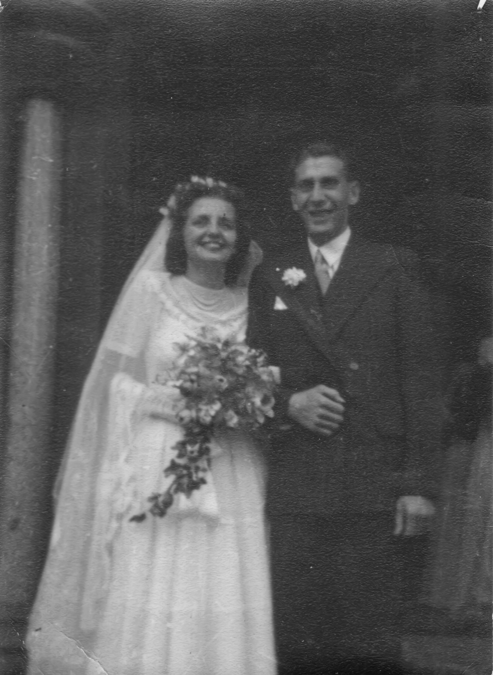
Val and Mailey on their wedding day.

During the 1950’s, Val and her husband Mailey lived in South Yarra, and Val’s parents (Mr & Mrs George Tuer), were living in a house close by.
Around 1956, Mr & Mrs Tuer moved to Hurstbridge because George – being a train driver – was stationed at Hurstbridge for a few years. They lived in a railway house on the creek side of the railway line.
Early in 1957, Val & family also moved from South Yarra to Hurstbridge & lived with Mr & Mrs Tuer until June of that year when they moved to Donald Street, Greensborough.
Around 1958, when George retired from the railways, Mr & Mrs Tuer moved from Hurstbridge to live in a flat downstairs at Val & Maileys house. Val has wonderful memories of those early years in Greensborough. Like so many other people, the recollection of going rabbiting with ferrets in the paddocks nearby, brought a smile to her face.
Val remembers:-
- There were no footpaths along Para Road Greensborough and pushing the pram was certainly ‘interesting.’
- Mr David Low, the local Taxi driver, who also lived in Donald Street – provided the transport at many local young ones weddings. Some of those that David knew quite well received the transport as a wedding present, as did Julie and Linda – Val’s daughters.
- The ‘crying room’ that was provided at the local Greensborough Pictures for mothers to take their babies to when necessary.
- The many, many, progressive dinners at Val & Mailey’s, the Cordner’s, and many other homes, as well as the bottle drives etc - to raise funds for the construction of the Greensborough swimming pool.

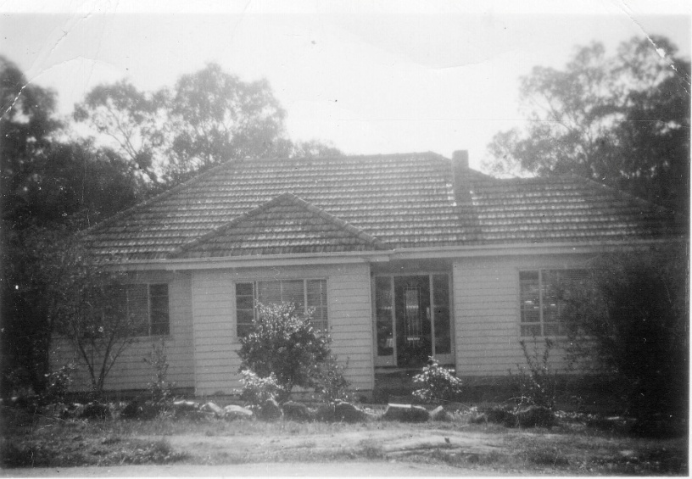
The Mallett family home in Donald Street, Greensborough

All these memories showed the pride and enjoyment Val shares with lots of early Greensborough residents in building and living in the township of Greensborough at that time.
The Mallett children (Linda & Julie) attended Greensborough State School, then later Watsonia High School. Val was Secretary of the Mothers’ Club at the State School, and held gym / pre-natal classes for the kinder mums at the kinder, near where Woolworths is now in Greensborough. The classes began with around 6 mums, and ended with around 40 mums 2 years later.
Val loved to play tennis, and several of the local women would play at the tennis court at the top of the cutting in Greensborough each week. Val also remembers many families that lived in the area at that time, one of which was Merilyn’s parents – Bill and Val Lewis, who were ‘Gillespie and Lewis’ – the furniture shop in Greensborough for many years.
In 1953, Mailey’s brother George was working for ‘Central Aircraft’ in the city. This was a shop that sold model aircraft. The owner of the shop wanted to sell the business, so George, Mailey and Ken (also Maileys brother) decided to purchase the shop in Princes Walk. They continued to run the business together from 1953 until around 1963. After that, Val and Mailey began ‘The Melbourne Hobby Centre’ in Port Phillip Arcade in the city, selling Scalectrix slot cars until around 1968, when the business ceased.
Mailey had been a stereotyper by trade – he previously worked for Southdown Press, who produced the New Idea. Mailey did artwork for the comic strip covers.
Around 1968, Val went to work for Commonwealth Industrial Gases (CIG) and remained working there until 1984. Every year, CIG would hold a big dinner at the MCG for the ’25 Year Club’ of approximately 140 employees who had worked at CIG for more than 25 years. As Val ran the 25 Year Club, it was up to her to organize the taxis for every person to be collected from, and returned to their home, in order for them to attend the dinner. Val continued to do this until around 2009, when CIG was sold to LINDE/BOC.
In 1989, Val and Mailey decided to subdivide their property in Donald Street. They built a new house and created Julinda Court which they named after their daughters – Julie and Linda. They remained living in Donald Street until 1990.
In 1992, the Greensborough Bowling Club was formed, but unfortunately they had no club rooms of their own, so they would use other bowling clubs facilities. In 1994, the Greensborough Bowling Club (GBC) was allotted land and title of the former Watsonia High School library as their club rooms, and that is where the club is presently located. Val and Mailey were not only regular bowlers, but Val was Secretary of the GBC for 14 years from 1996, and still attends the club nearly every day.
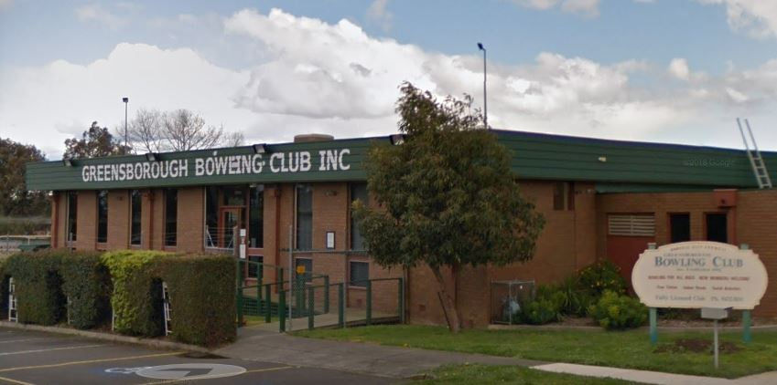
Greensborough Bowling Club (from Google 2018)
Merilyn and I had a most enjoyable time with Val, and we left with an invitation to call in again for a chat.
Dawn Bennetts Merilyn Mullavey

