**Vernon Draffin**

George Draffin married Florence Mease on 6 July 1917, Vernon Roy Draffin was born 4 May 1921.

He served in WW2 VX146358. I

n June 1956 he was engaged to Ada Elizabeth Buchanan and on 12 January 1957 he married Ada. They are on the Electoral rolls living at 70 Alexandra Street, Greensborough from1963 to 1980.

Sadly Vernon passed away on 19 July 1993 in Heidelberg, and Ada on the 20 September 1999, they are both at Fawkner Memorial Park both cremated.

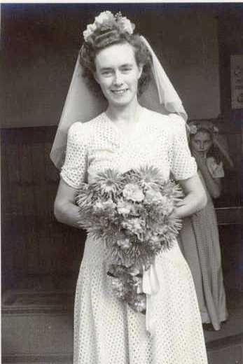 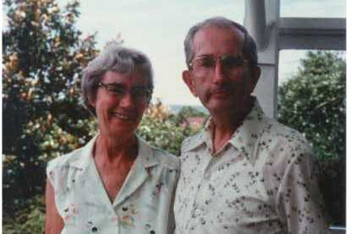

Ada Ada and Vernon Draffin (Ancestry photos)

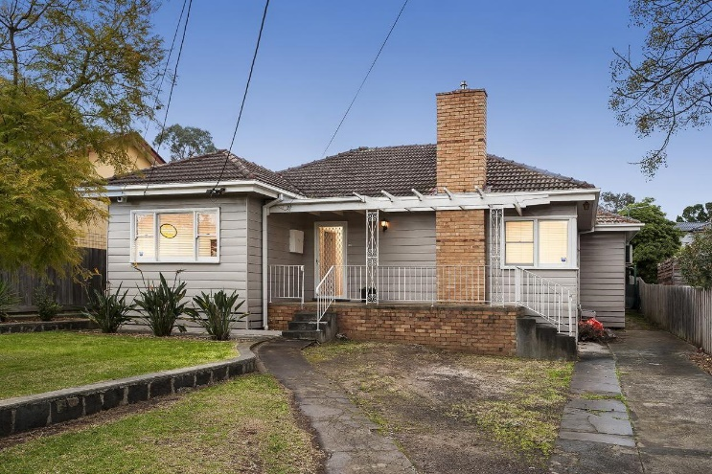

70 Alexandra Street, Greensborough, Darren Jones photo 2017.

The Argus. 16 June, 1956.

BUCHANAN–DRAFFIN. The engagement is announced of Ada Elizabeth, fifth daughter of the Late Mr. and Mrs. G. A. Buchanan, of Flemington, to Vernon Roy, eldest son of Mrs. and the late Mr. G. F. Draffin, of Flemington.

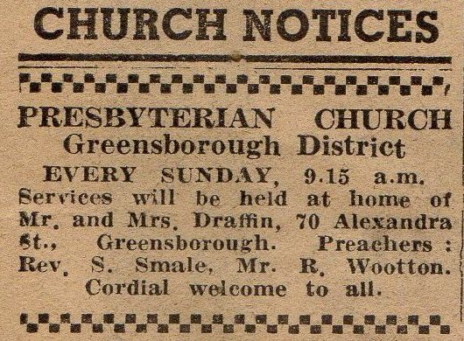

Diamond Valley Mirror. 14 September 1960.

MARILYN SMITH 2018