Keith WILKIE

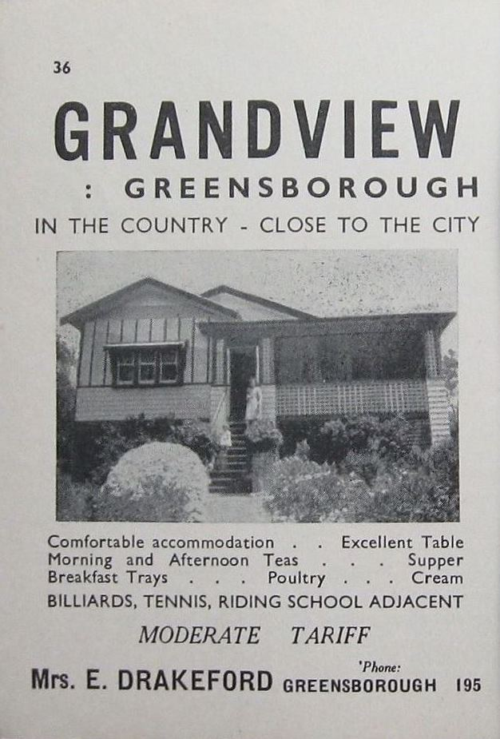
Keith Wilkie & Rose-Marie lived at 57 Greenhills Road, Greensborough from 1967 to 1972 on the electoral Roll. This house was Grandview.

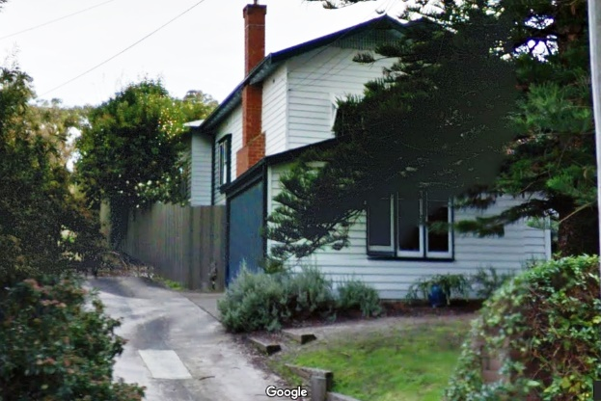
57 Greenhills Rd, 2018
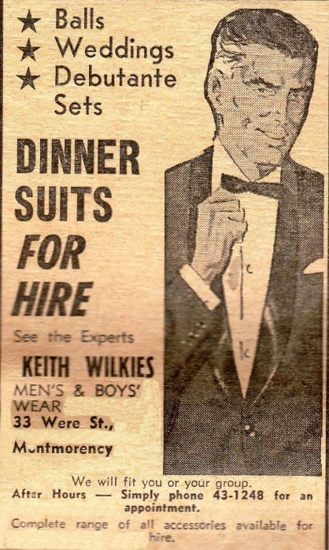
Diamond Valley News 28.11.1967

Keith had the Men’s and Boy’s Wear shop at 33 Were Street, Montmorency
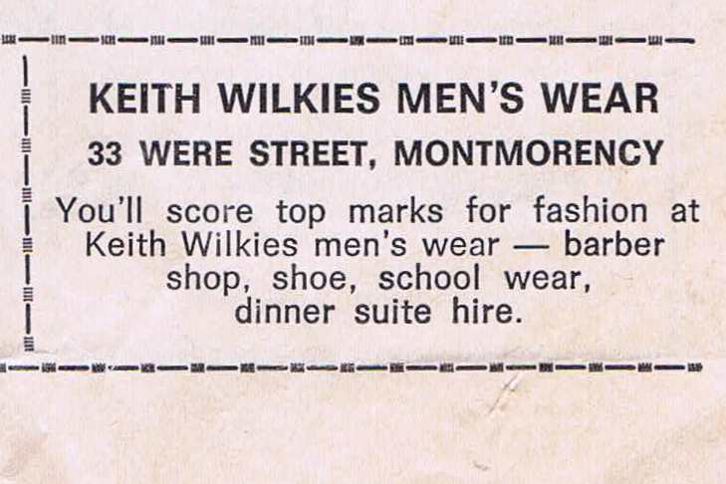
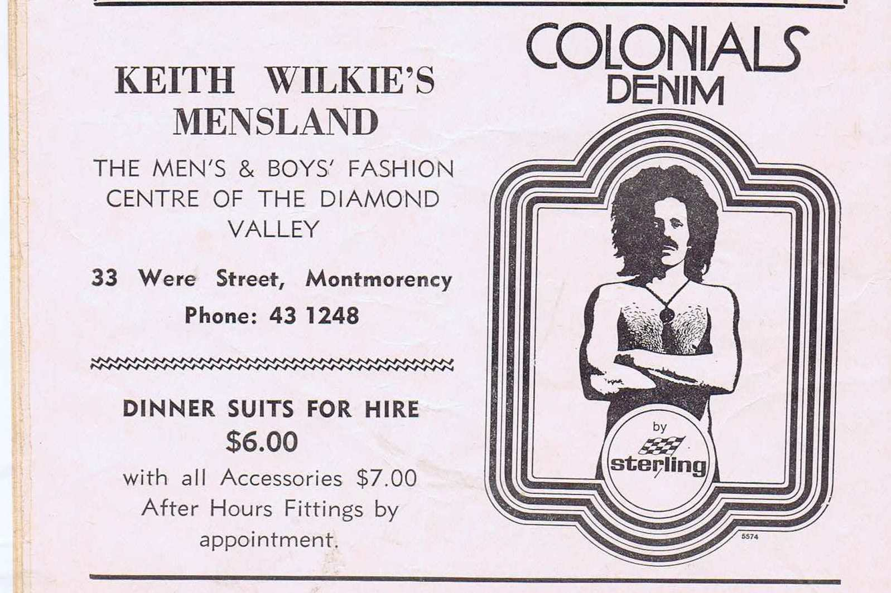
DV Football Record.15.7.1972
DV Football Record 6.6.1970

