Laguna Hair

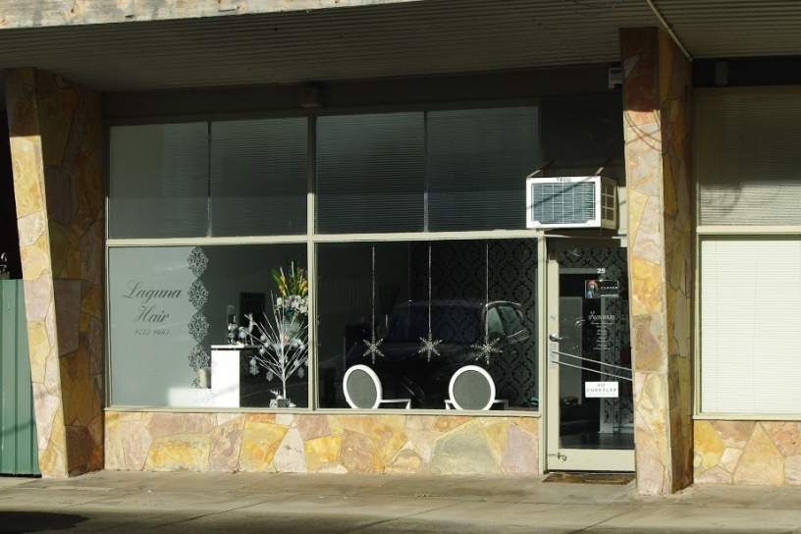

Photo taken January 2018
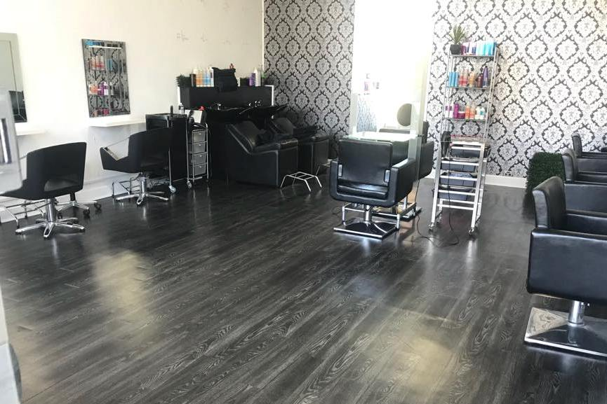

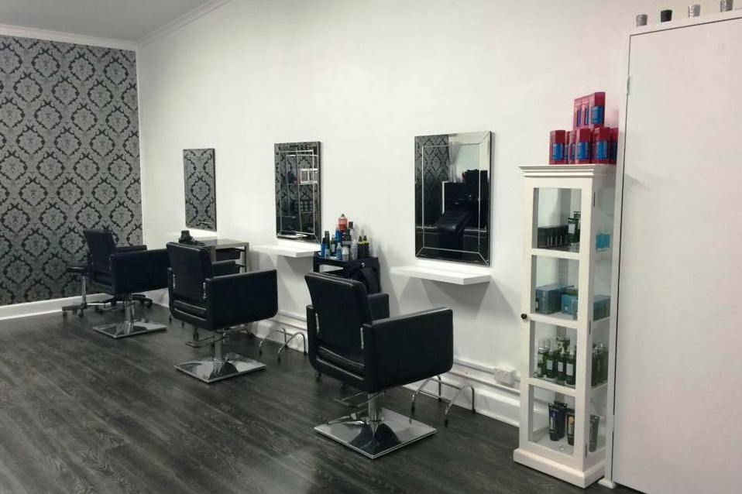

Hair Stylists Faye Schembri and Michael Tedford.
Faye has been there 4 years in April 2019. Before that Faye
was at 137 Main Street, Greensborough, that is now
Empire Hair & Body.

Marilyn Smith.

