Songs & Shoes

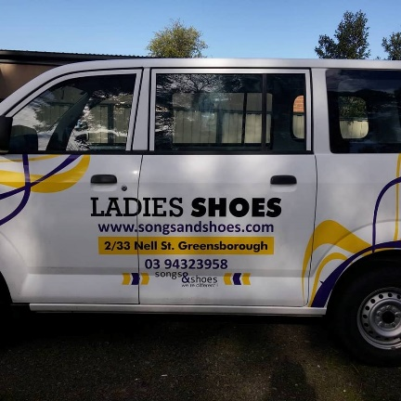

From Face Book. Business Card. 14.10. 2018.

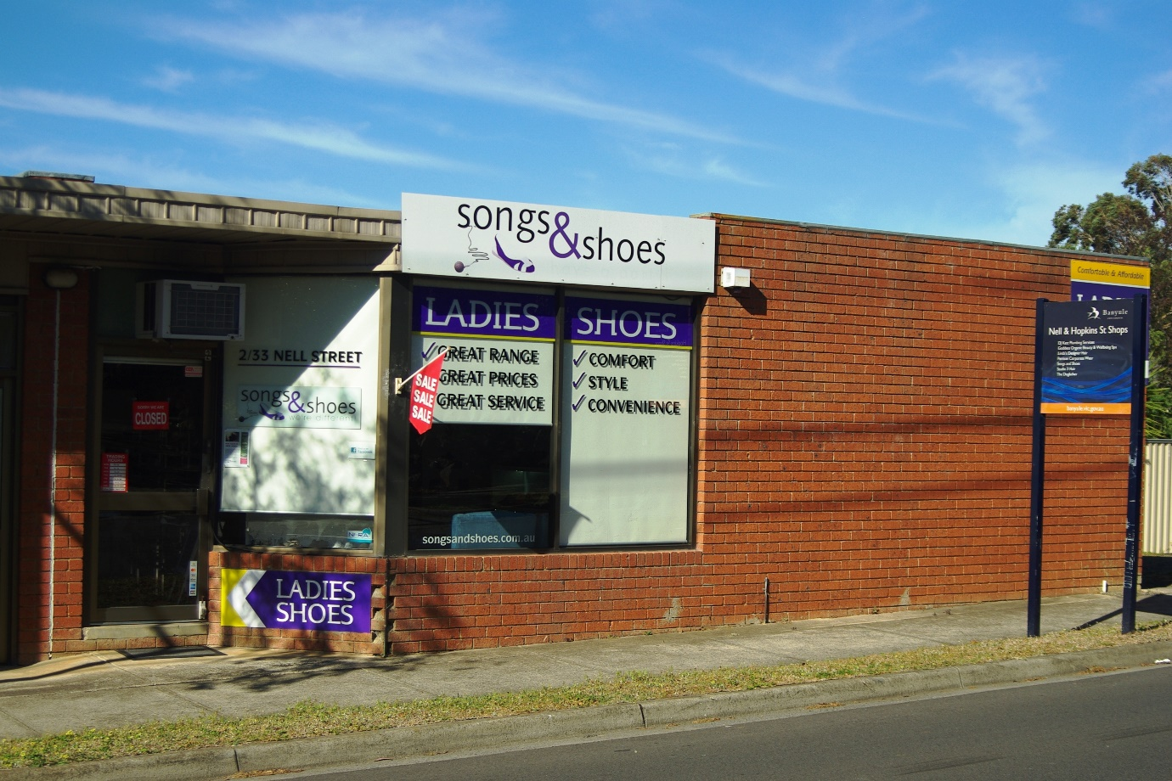

2/33 Nell Street, Greensborough. Photo taken 14.10.2018.

MARILYN SMITH

