Greensborough Station, 1980s

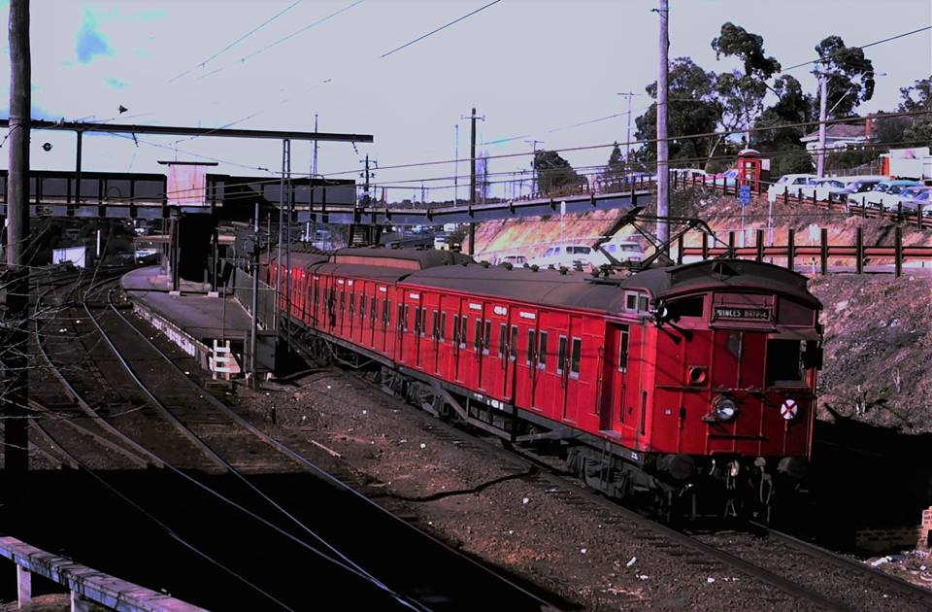

Old railway stations across Australia

Raymond Marsh
August 24, 2018
Victorian Railways got good value from much of its rolling stock. Another 'Tait' train leaves Greensborough Station for Princes Bridge Station Melbourne in the 1980s.

