Watsonia Timber Supply, Old Greensborough Road, Watsonia

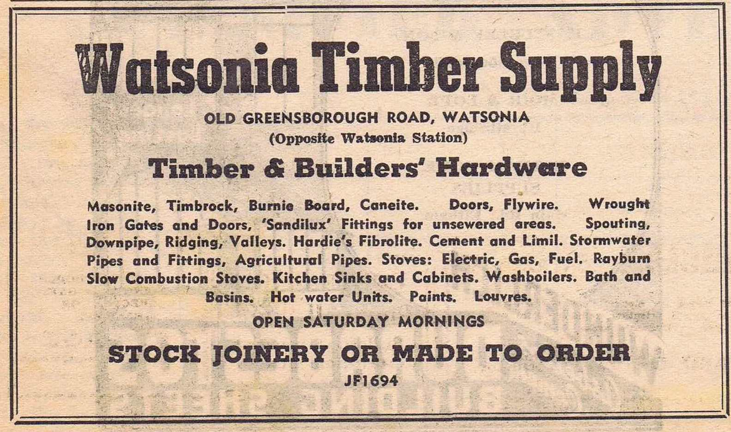
24 February, 1955 Diamond Valley Local.

The Argus 25 May 1956.
WATSONIA TIMBER SUPPLY
Old Greensborough Road, Watsonia. JF 1694
Radiata Pine for every need in your Contemporary Home.

21 August, 1973 Diamond Valley News.

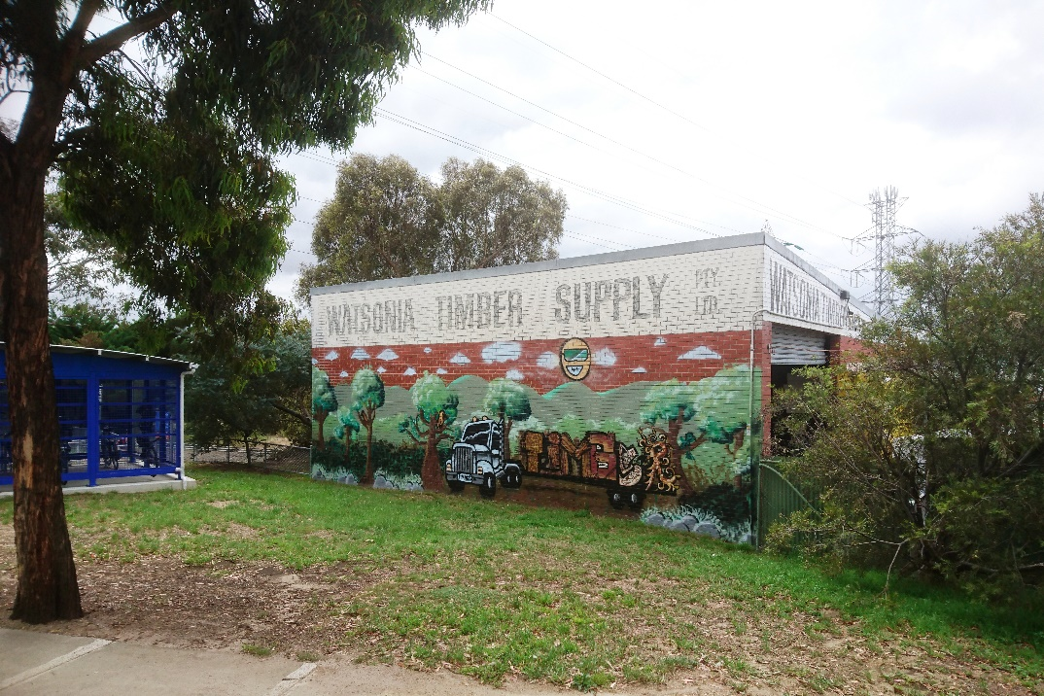
Watsonia Timber Supply taken 2015.

Marilyn Smith.

