Montmorency Timber Co. Were Street Montmorency

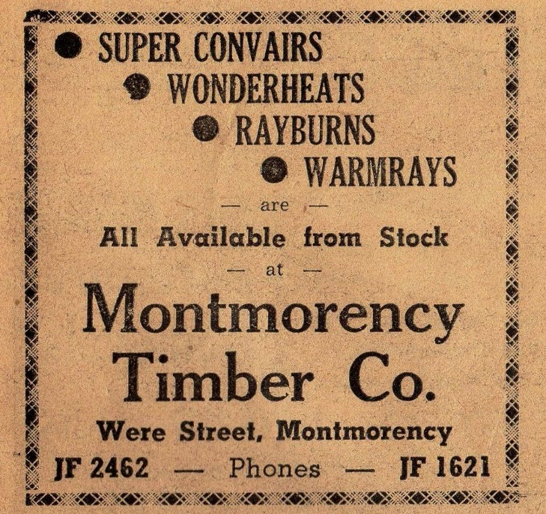

Diamond Valley Mirror. 14 September, 1960

