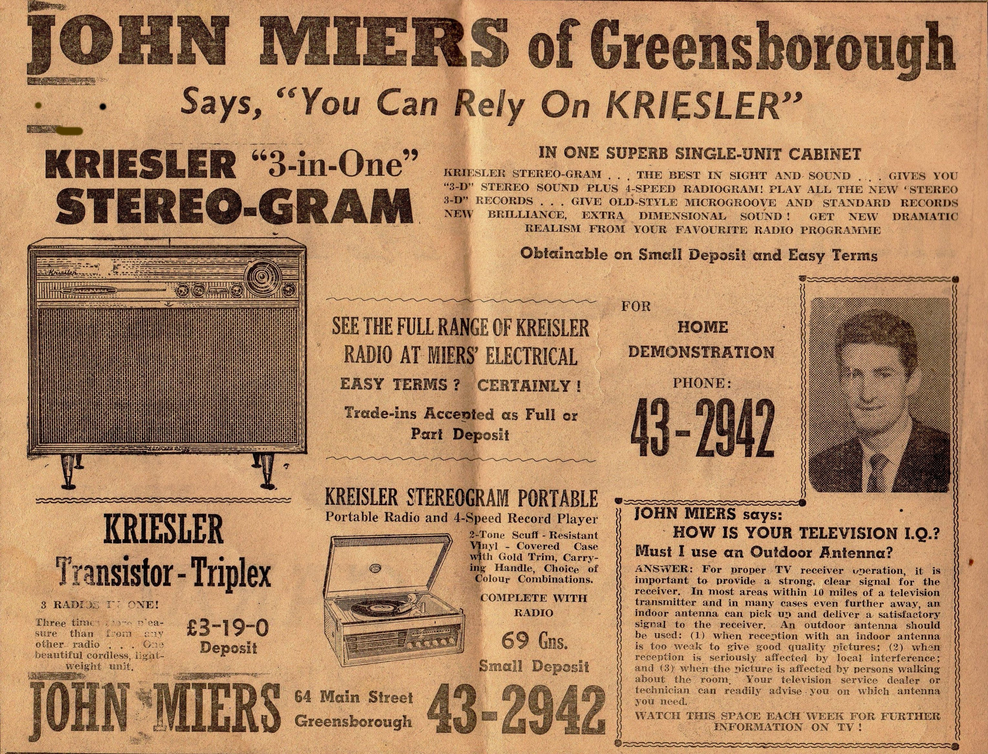
Diamond Valley Mirror. 14 September, 1960.

John Miers was on the Electoral rolls 1967 & 1968 living at 8 Santon Street, Greensborough. Listed as Company Director.

Marilyn Smith.

