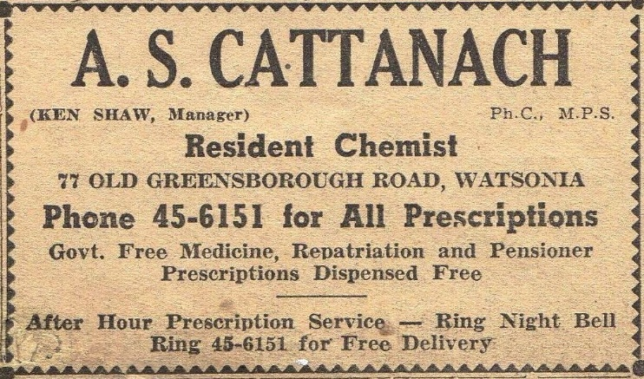 14 September, 1960. Diamond Valley Mirror.

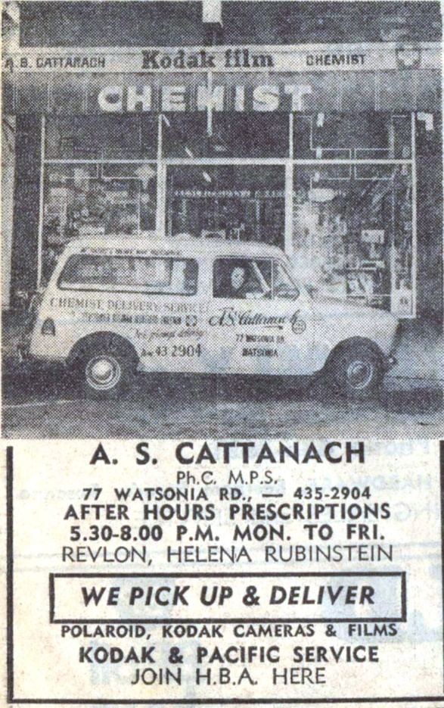 21 August, 1973. Diamond Valley News.

Alfred Stephen Cattanach lived in Ivanhoe, he was a Chemist. He owned the Chemist, Kenneth Shaw was also a Chemist and he was the Manager of his shop in 77 Old Greensborough Road, Watsonia. Kenneth lived at this address with his wife Pamela.
Alfred enlisted in WW11 Service No. 118066.

On the 24 February, 1947 Alfred Cattanach had an Announcement in The Evening Advocate Q’land saying he was opening a business as a Pharmaceutical Chemist in Innisfall.
Marilyn Smith 2019

