Alan John Ely (1940- )
Alan John Ely is the son of Alan Reginald and Maisie Violet Ely and was born c1940 in Greensborough.
In 1963 was living at 53 Grimshaw Street, Greensborough, he was a Clerk.

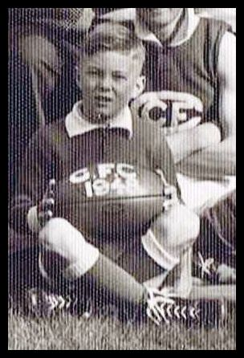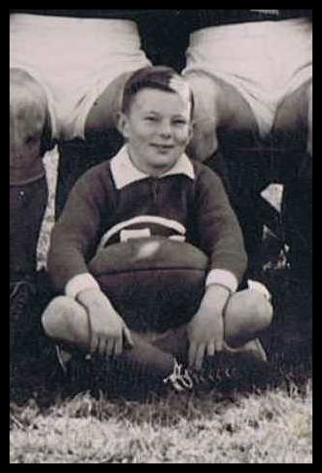
1948 Mascot. 1949 Runners-Up.

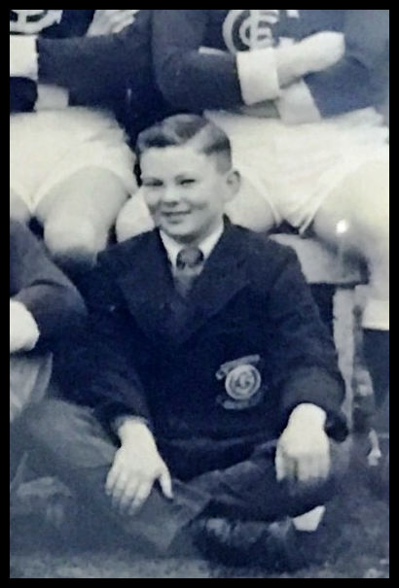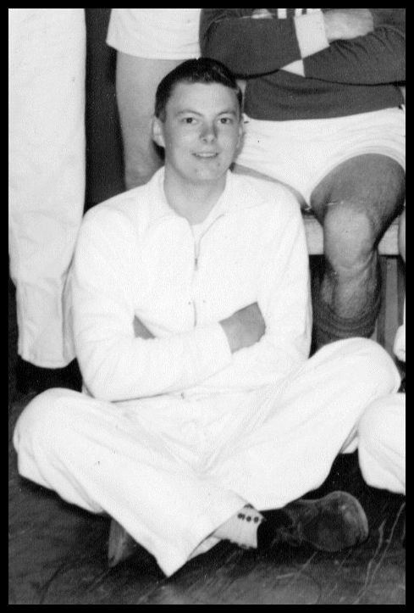
1952 Premiers 1958 Trainer.
(G.H.C. Photo’s)

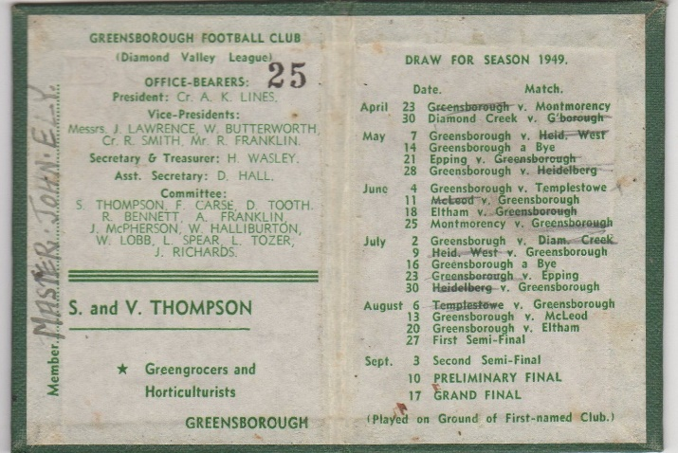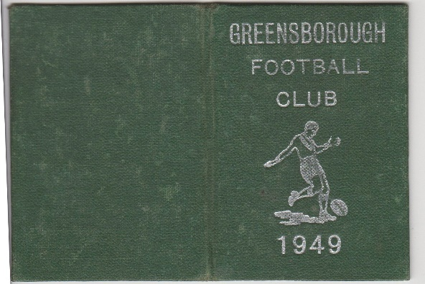
Greensborough Football Club 1949.

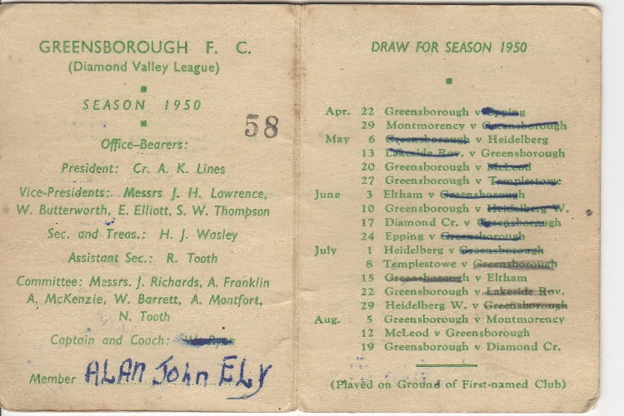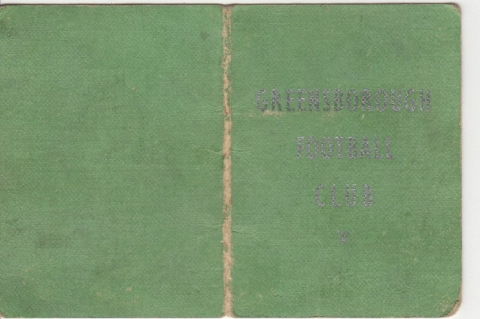
Greensborough Football Club Season 1950.
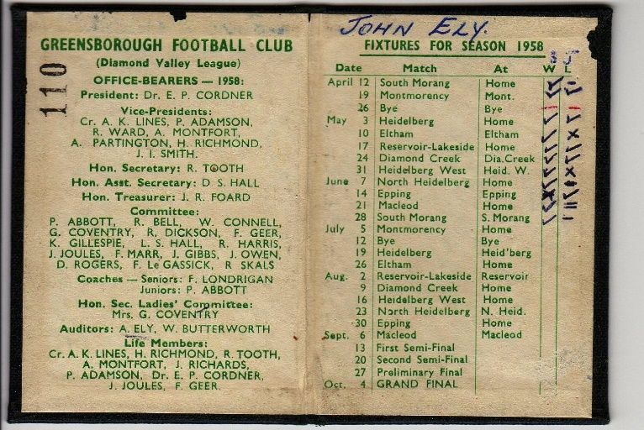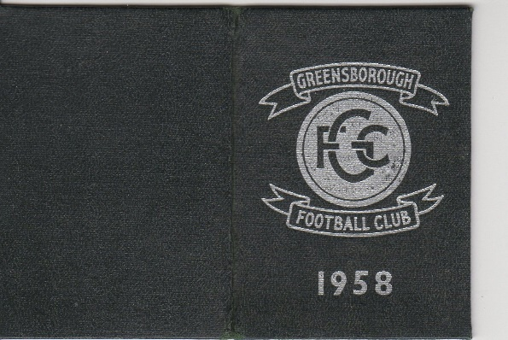
Greensborough Football Club Season 1958. (Gary Partington’s member’s tickets)
Alan moved to South Australia.

Marilyn Smith. 2019.

