Philip Oliver Ely (1907-1957)
Frederick Ely and Elizabeth Poulter, their son John Ely married Melinda Iredale in1907. Philip is their 1st born son.

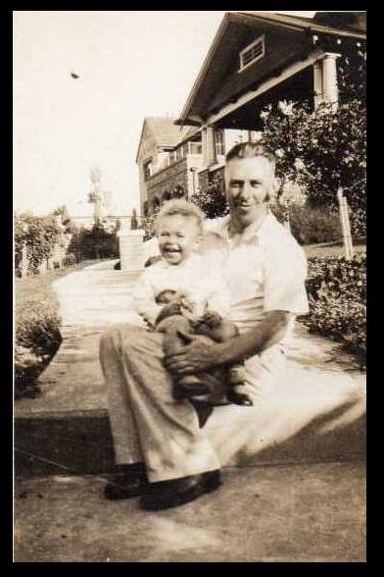

Philip Oliver Ely with baby George Guthrie outside the Ely house in Greensborough. (Ancestry Photo)

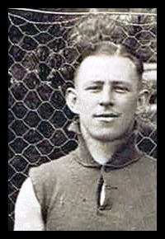

Philip Oliver Ely Greensborough Premiership team Photo 1931 (G.H.C Photo)

Philip was born 27 September, 1907 in Greensborough. Philip married Linda Janet Skewes in 1935, in 1954 he was living in Eaglemont, he was a Clerk. Sadly passed away 7 July 1957 age 49, he was cremated 10 July, 1957 His wife Linda born 1908 Deptford, Victoria, passed away 3 August, 1989 age 81, she was cremated 9 August, 1989. Both cremated at Springvale Botanical Cemetery.

Advertiser (Hurstbridge) 2 April, 1931
Our popular young townsman, Mr. P. Oliver Ely, intends spending his
annual holiday at his aunt's (Mr. Armstrong) in Adelaide, S.A. Mr.
Armstrong was for a long period the esteemed manager of the local
Bank.

Advertiser (Hurstbridge) 8 March, 1935.

Wedding Bells. Ely-Skewes.
A full choral service marked a very pretty wedding in the Church of the
Epiphany, Northcote, on Saturday afternoon, March 2, when the wedding of Linda Janet, elder daughter of Mr. and Mrs. J. A. Skewes, of
Gipps street, Collingwood, and Philip Oliver, eldest son of Mr. and
Mrs. J. Ely, of Grimshaw Street, Greensborough, was celebrated.
The Rev. T. Cole officiated. The bride was given away by her father, and
was attended by one bridesmaid, Miss Maisie Love. Chalk white lace and flat crepe combined to form the bridal gown, which was made on close fitting lines, with a soft cowl neck and sleeves, and finished with a flowing train. A lace veil, lent by Mrs. J. Tidwell was mounted on masses of white tulle, and the bride carried a shower bouquet of water lilies. The
bridesmaid wore a slightly trained frock of coral pink flat crepe, with stiff
frills falling from knee to hemline, and trimming the neckline and shoulders.
A matching lattice cap was worn and she carried a shower bouquet of
Gladioli, cactus dahlias and delphiniums. The bridegroom's brother, Mr.
Alan Ely was best man. After the ceremony relatives were entertained at
Wedding tea at the home of Mrs. Wright, 522 High Street, Northcote. The beautiful wedding cake (two tier) was made by the bridegroom's mother.
The bride's mother wore a blue and white check gown and hat to match,
and carried a bouquet of red gladioli. The bride groom's mother wore a
navy blue swagger suit, with a spray of autumn tinted tiger lilies on her
shoulder.

The Herald Sun 20 November, 1937.
THREE ATTACHES BY INTRUDERS
Robbery Attempts
Intruders attacked two men and a woman at their homes Collingwood,
Eaglemont and the City last night, after they had been disturbed while
breaking into the premises. Each attempt at robbery failed. Mr Philip Oliver Ely, of Wimbledon Grove, Eaglemont, was returning home at 8.20 p.m. when he saw a truck parked outside his house, with a man sitting in the cabin. As he walked up the drive, the horn was sounded twice and the truck driven slowly away. As Mr Ely walked along the side a man came from the back of the house, and said, "Is that you. Bill?" When he saw Mr Ely, he ran to the back fence, but was grabbed by the leg. The man struck Mr. Ely several blows on the head with a blunt instrument, and escaped. An attempt had been made to force a sleep-out door. Mr Ely was treated by a doctor, and then taken to a private hospital, where he was detained for observation.

The Age 29 May 1953.
AT HEIDELBERG
Another auxiliary needing new members is the Heidelberg auxiliary to
Ravenswood, the home for elderly women conducted at Ivanhoe, by the
Melbourne Ladies Benevolent Society. This band of women and
there are only about live active members, pays regular visits to the 34
residents at Ravenswood, taking them-tea and spending the after
noon with them. The members are led: by Mrs. P. O. Ely and Mrs. C.
Sturtevant. Mrs. Ely and Mrs. Sturtevant are anxious to improve
the auxiliary and hold regular functions to raise money for extras and
amenities at the home. Those interested in joining them are asked to
ring Mrs. Ely at JL2081.

Marilyn Smith. 2019.

