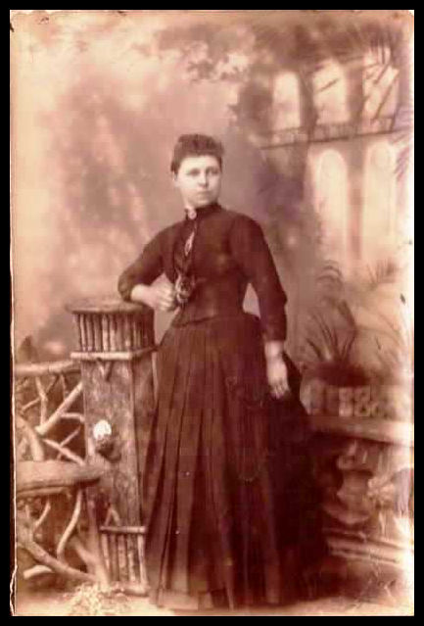 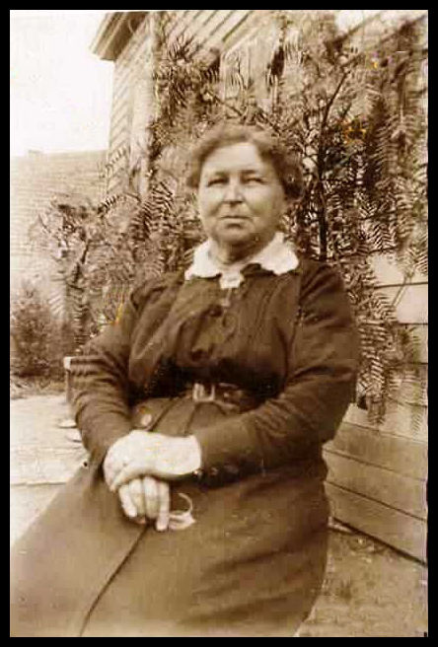

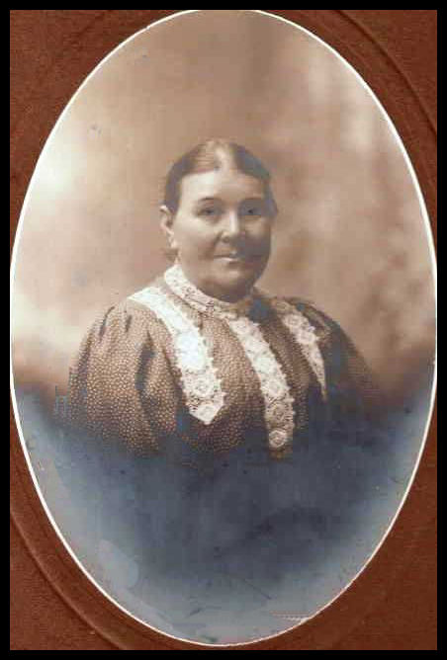 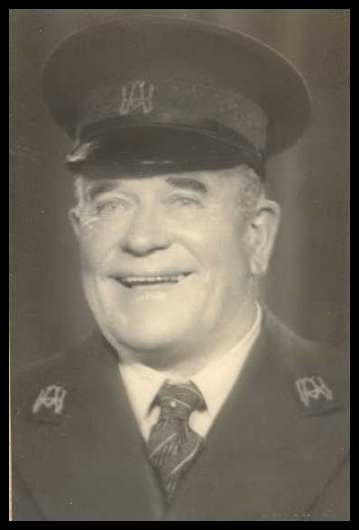

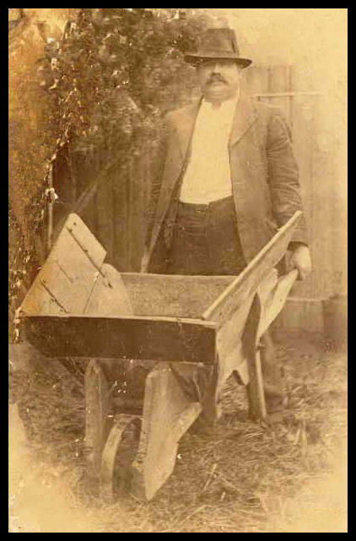

Sarah and George Staines (Ancestry Photos)

Sarah Ely is the 1st born child of Frederick and Elizabeth Ely. Sarah was born in Greensborough 1867, she married George Henry Staines in 1889, and sadly Sarah died on the 12 July, 1953 in Black Rock.

George Henry Staines was the son of George and Elizabeth Staines George was born in Penrith, N.S.W.1867, sadly he died Carlton North 1945. They had 9 children, 8 sons and 1 daughter.

The Age 27 July 1898. 1st born son

Staines-On the 25th July, at his parent’s residence, 143 Amess-street, North Carlton, George Henry, the dearly loved eldest son of George Henry and Sarah Staines, aged 8 years and 4 months.

A little sufferer gone to rest.

The Age 27 July 1898.

STAINES-The Friends of Mr. GEORGE HENRY and Sarah Staines are

respectfully invited to follow the remains of their late beloved oldest son

George Henry, to the place of interment, the Melbourne General

Cemetery. The funeral is appointed to move from their residence, 113

Amess street, North Carlton. THIS DAY (Wednesday), 27th, at 2 o'clock

The Age 25 April, 1914.

Staines-Ely (Silver Wedding)—On the 21th April, 1889, at Carlton,

George Henry, eldest son of the late George Henry and Eliza Staines,

to Sarah, eldest daughter of Frederick and Elizabeth Ely, Greensborough,

Present Address McIlwraith Street, North Carlton

The Age 25 May 1945.

STAINES-On May 24, at 198 McIlwraith-street, North Carlton, George

Henry, beloved husband of Sarah, and loving father of George (dec.),

Norman, Sydney, Clarence, Charles, Reginald, Rupert, Elizabeth (dec.) and

Wilbur, aged 77 years. He wipes the tears from every eye.

Marilyn Smith. 2019.