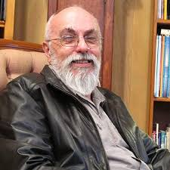
David Hay was born in Sydney, in 1948. Until the age of seven, he lived in Lindfield and then his family moved to St Lucia, a suburb of Brisbane. In 1960, when David was twelve, his father accepted a position in Melbourne, and the family set up house in Croydon.

David attended Camberwell Grammar, and after completing secondary education, worked for ICI. In 1968 David was called up for National Service and spent 1969 in Vietnam, as a Trooper with the First Armoured Regiment. As the radio operator in a Centurion tank, David was involved in the battle of Binh Ba on 6th June, 1969, the biggest conflict for Australian armour during the war, and one of four landmark battles fought by Australians in Vietnam. He was wounded, but returned to active duty after a stint in hospital.

David was discharged from active service in February, 1970, and in April of that year he married Leigh Talbot, at St John the Divine Anglican Church, Croydon. Leigh and David had met many years previous at the Young Anglican Fellowship at St John’s.
Before conscription, David had commenced a Diploma in Chemistry at Swinburne College. On discharge, he went back to studies and completed his Diploma at the Royal Melbourne Institute of Technology. He then decided to enrol in an Honours year at La Trobe University. He achieved a first class honours (H1) and then enrolled to do a PhD in crystallography, under the supervision of Dr Maureen Mackay.
David completed his PhD in 1981 and re-commenced his working life at the Commonwealth Explosives factory at Maribyrnong, but within months, had accepted a position with CSIRO. David spent the rest of his working life with CSIRO, working in areas of materials science, using his crystallographic knowledge as Principal Research Scientist, while also managing a research team. David retired from CSIRO in 2012, but continued his scientific pursuits with CSIRO as an Honorary Fellow for the next 5 years.
In 1972, David and Leigh had bought a house in Greensborough. In 1987 David was concerned to learn that the then Shire of Diamond Valley was considering demolishing the public swimming pool in Flintoff Street, so wrote a protest letter to the Diamond Valley News. Within days, people from the local Greensborough community had contacted David, pressuring him to call a public meeting, which he did. Expecting a few people to attend, he was staggered when close to 50 people
arrived at his home.
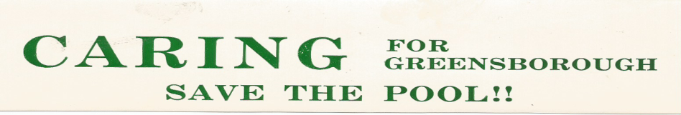
The community voted to form a group and CARING (Concerned Active Residents in Greensborough) came into being – a name David had chosen. CARING got off to a flying start by nominating Ian Wallace for Council, then David and finally Les Smith, all Central Riding residents, independent of any political party. The pressure to save the pool was successful.

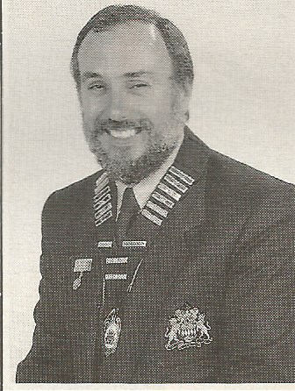
David was first elected Shire President in 1993 and again in 1994 and is quick to say that he “was the first DV Shire President to be sacked by the Kennett Government” with Diamond Valley subsumed into the newly formed City of Banyule with the forced amalgamations of local governments in that year. David was a DV Shire Councillor for eight years in total and relates that although he thoroughly enjoyed his years on council, and learned a lot from the experience, he has never had ambitions to continue a career in politics.
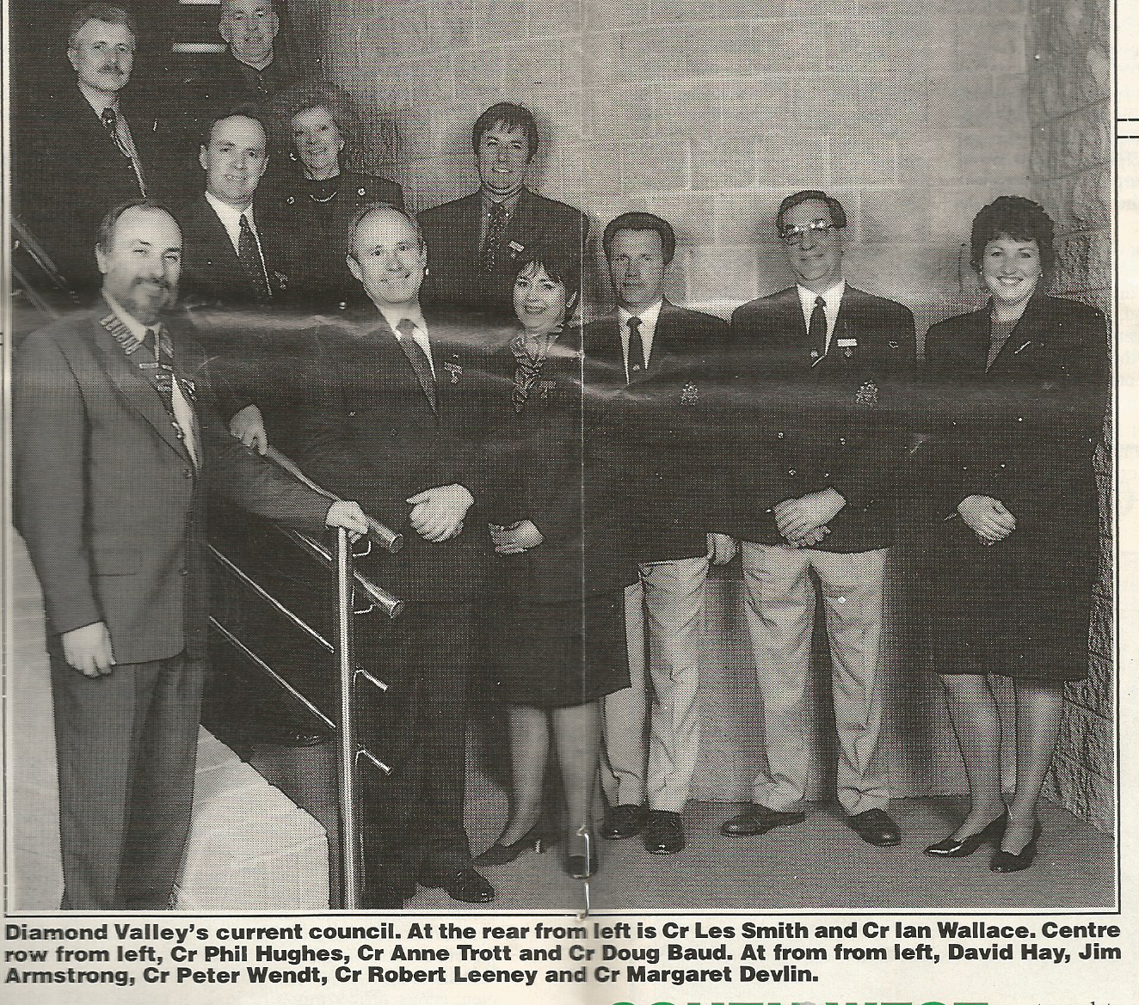
The three independent members of the Central Riding which accommodated 12,500 of the Shire’s population set to work to serve the community. This they did very well. They had the vision and were responsible for many improvements. Among these were the upgrading and building of the rotunda in War Memorial Park, opening the bowling club, making improvements to Kalparrin Gardens and retaining public open space. These are our treasures enjoyed by the public today.
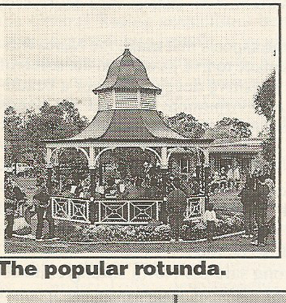
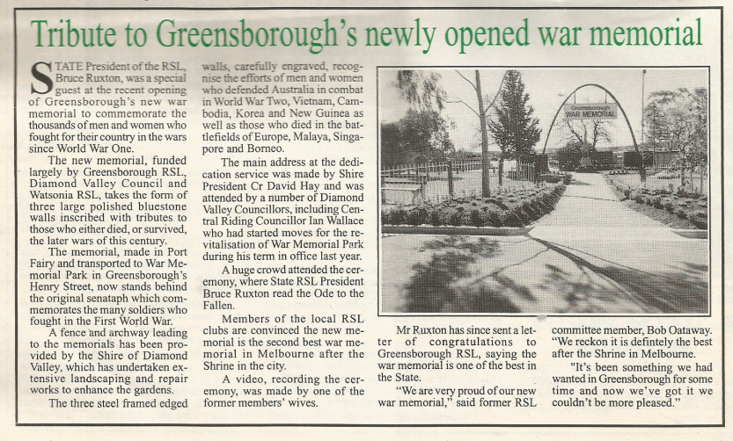
Such vision by three independent Councillors.

In retirement, David and his wife Leigh run Tales from the Treehouse – a writing cooperative and publishing enterprise to help promote their own authored works, as well as titles of other selected authors. For decades, David has been an avid collector of clocks and old scientific equipment. In retirement he writes, travels and enjoys quiet time in his home of 50 years.
So life goes on, but sometimes the past catches up.
In 2019 David, along with the Officer Commanding 1st Armoured Regiment in Vietnam, was invited to lay a wreath at a commemoration service in Canberra on the occasion of the 50th anniversary of the battle of Binh Ba. A particular highlight of the occasion was his unexpected and emotional first-time meeting with the helicopter gunship crewman who saved the lives of the tank crew.
David’s tank was under intense rocket fire which had disabled the guns and left the tank defenceless. If not for the timely arrival of the gunship, it would undoubtedly have been overrun.

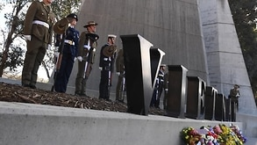
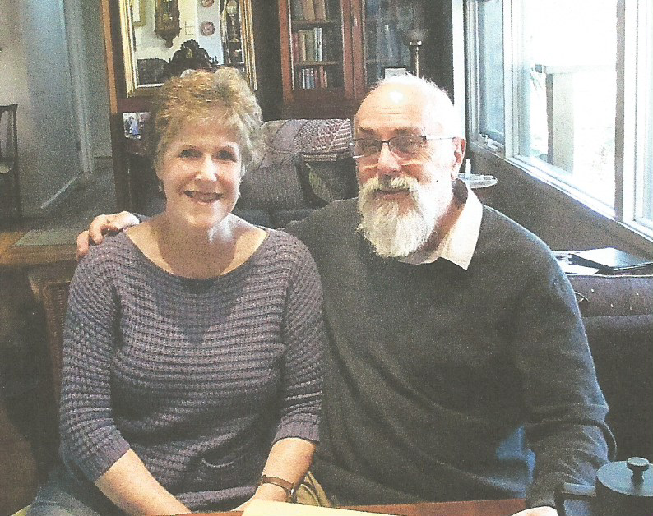
I have known Leigh and David Hay for many years.

I first met David when he was my Councillor in the Central Riding and Leigh when I joined as a foundation member of the local fm radio. We became firm friends and I am pleased to say that we still are.

I really want to pay tribute and thank them so much for all that they have done for the local community and especially me.
Leigh was so very kind to edit and give me sound advice about my book which I wrote about my dad’s war service. I am so grateful.
And David always listens and his advice has been invaluable.
Thank you both Rosie Bray

