Hurstbridge Train Line
19 Jun 2014
The Hurstbridge line is 100 years old this week. It was originally built to transport apples and it still has Australia's only remaining non-automated signalling system for train drivers. Drivers must hand a staff to each other at Eltham station to make sure no other train is further up the line. The system is perfectly safe, but slow, and is due to be phased out before the end of the year.
http://www.theage.com.au/photogallery/national/hurstbridge-train-line-turns-100-years-old-20120619-20lv1.html?selectedImage=0
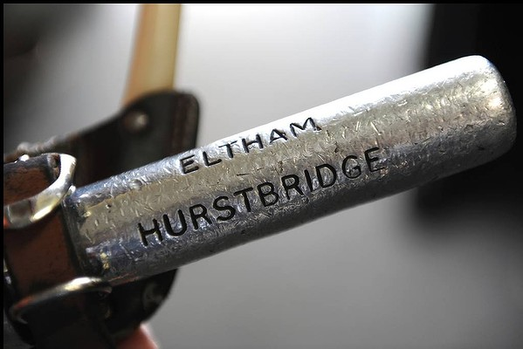
Drivers carry a staff between Eltham and Hurstbridge stations to enable the trains to travel between stations. Photo: Craig Abraham
