Rosie Bray Anne-Marie Primmer.
BY DEFAULT, OR BY DESIGN.
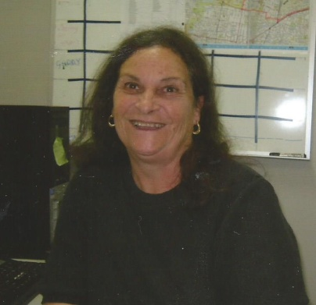
I have known Anne-Marie Primmer since 1957, when she attended with her brothers at the Reservoir Baptist Sunday School, where I taught Sunday School to the preps and the junior classes. At this time, it was a large Sunday School with Hazel Taylor in charge of the preps and junior schools and Bob Hayes in charge of the senior school. The Sunday School superintendent was Gordon Peacock.
Anne-Marie was a delight to have in class, as were her brothers. The Primmer family used to always attend all the Sunday School events like Anniversaries etc, so I got to know the family quite well. I met up with Anne Marie again after many years at a Diamond Valley Community Information AGM where she had been working as a volunteer since 1986
When I say that I knew Anne-Marie, I thought that I did, but I could not have been more wrong--- After a short talk to Anne-Marie recently, I found that this young Sunday School student had done so much with her life that it could take another person 100 years to have achieved.
And I am so proud to know her.
Anne-Marie’s life could be divided into four parts
Whether by default or design each part wove the tapestry of Anne-Marie's full life
Anne-Marie was born in East Melbourne & lived her young life in Reservoir with her mother, father and two brothers. All of the children attended the Keon Park State School, with Anne-Marie going on to Merrilands High School and later beginning a diploma of Fine Arts at Preston Institute of Technology.
Anne-Marie’s professional life began so innocently, when she read an advertisement in the paper requiring a receptionist at a legal office. Anne-Marie applied and got the job, and became absorbed in legal aspects of daily life....so much so that she studied and gained her Diploma of Legal Studies and became a Legal Executive working in suburban and city offices. Anne- Marie is still active in the legal service today and is a Fellow of the Institute of Legal Executives.
Anne-Marie’s father was a good cook and her mother used to enter her lovely roses and irises in the Whittlesea Show. One day in the early 1970s Mrs Primmer casually suggested that Anne-Marie might like to enter in the cake section of the Whittlesea Show. It was only a throwaway line “You make a nice nut loaf” which was the spring board for Anne-Marie’s very first effort into competition cooking. And it won first prize. Who would have thought that a simple nut loaf would lead to an absolute new world of cookery, preserves, confectionary, presenting and exhibiting for Anne-Marie, who says that making new friends at each show is the best part.
Nowadays Anne-Maries kitchen goes into ‘lock down for five months before the Royal Melbourne Show and she has won every possible award including the coveted Mc Robert Memorial Trophy for the 11th time, breaking all records. She is a Victorian Agricultural Show Judge and travels around Victoria, judging and sharing her knowledge with exhibitors and the general public. Anne-Marie is always keen to help others by passing on confidence and encouragement where needed.
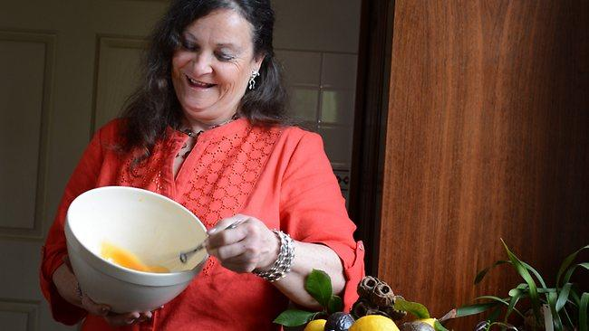
Anne-Marie’s involvement with dogs just happened, when a neighbour’s dog seemed to spend more time at Anne-Marie’s house than their own. When the neighbour shifted the dog just stayed and Anne-Marie began her third interesting part of her life, training dogs. Anne-Marie soon realised that some dogs have trouble in socialising and instead of the old chain method; “there was another way of showing kindness”. Anne-Marie’s dog journey with dogs has taken her to becoming a qualified trainer, a mentor and senior instructor with the Kintala Dog Club in Heidelberg and the Gentle Dog Trainers Association. Anne-Marie can be seen at festivals such as the Banyule Festival each yea
Anne-Marie’s fourth section of her life has really mingled with the other three; because from a young age she has always been a community volunteer in some way or other (even at the age of eight, Anne-Marie was active in raising funds for the Red Cross). Anne-Marie began volunteering with the then Diamond Valley/Eltham Citizens Advice Bureau (still called the bureau by the old timers) in 1986. She felt that with an active Legal Executive background she may be able to give something back to the community. How right she was, as over the years her wisdom and counselling have been invaluable. When asked about working with the members of the Bureau, Anne-Marie answered that she enjoyed being able to help those in need and particularly liked helping with the statistics, sharing the Statistics team role with Betty Matthews.
I would like to pay tribute to Anne-Marie Primmer ---Legal Executive, Master Cook, Dog Trainer and Community Worker extraordinaire. Please take some moments to ponder??
Were these four sections of her life by default or design??
I am so proud to know Anne-Marie Primmer. Rosie Bray.

