Amy Clayton and family

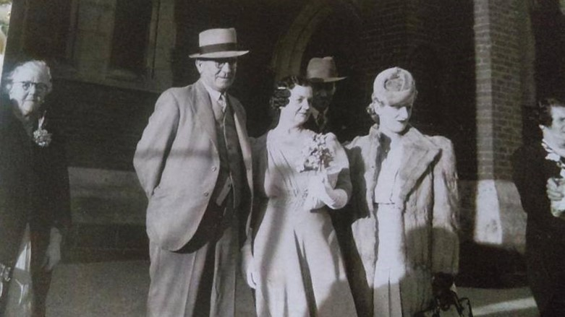

Vicki Wilson Greensborough & Diamond Valley forgotten memories.... what’s your story?
Far left is Amy Clayton my Great Grandmother, (Greensborough, who owned tea rooms Henry St.) her Son Wilfred (whom I knew as a little girl) my dear Nan Ivy (Amy's daughter) Wilfred's partner Esme and on corner of photo is one of Ivy's sisters Gladys. Church is South Preston (our church) where Mum and Dad were married. Would probably be Mum's wedding or Aunty Dais and Uncle Cliff's.
Sandy Anton Amy is the lady whose son was killed at war when she had the tea rooms and his name is on the Greensborough memorial...l think that’s right..
Vicki Wilson Yes Sandy Ernest Frederick Clayton and yes on the memorial at Greensborough.
Sandy Anton Amy started the tea rooms.. which went on to be Foard’s corner store in later years.. where Safeway is now
Vicki Wilson They really do bring back memories Faye, and seeing something for the very first time to me is extremely special. A little 'hello' from above perhaps. The strange thing is, many of the photos that I was sent, were from Dad's side not the Clayton side. I figure my Grandfather may have done copies (he had a dark room down the back of yard) and printed his own photos. Nevertheless, so glad that my cousin sent them to me.
Vicki Wilson I have many of my dear Grandfather's photos. Actually the majority of the old ones are from his doing. A beautiful soul whom I adored. He passed when I was four, but I can still visualize times with him. Love is forever.

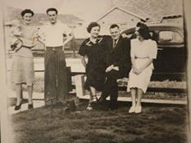

Vicki Wilson I only received this photo last week.
Jo Petrovic Vicki, you're dad's the handsome young fella with his hands on his hips?
Vicki Wilson My Grandfather seated with Ivy (Clayton) his wife and Daughter Daisy (Mum's sister)
Vicki Wilson And again, holding me. He was a very sick man (from the War...breathing problems)

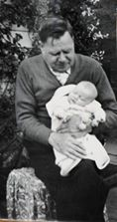

Faye Fort Oh how lovely to have this one Especially when he passed a short time later. But at least you got to know him a little
Vicki Wilson True Faye. He used to sit me on his lap and teach me how to draw (I have his drawings and one from World War 1 !! It is of his mates) He was a brilliant artist and so clever with anything that he tackled. He did all of the tiling in our family home of 74 years. It's still stands and is just beautiful.

