Ashril Theatre
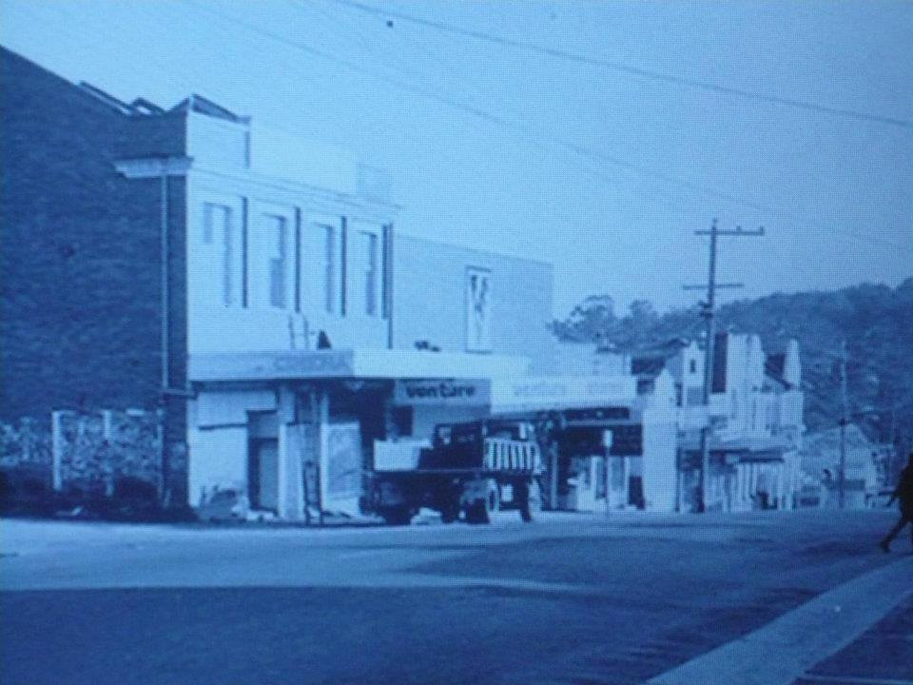
Photo from Sandy Anton ‎I GREW UP IN THE GREENSBOROUGH DISTRICT
Bev Burgoyne The owner was Lou Riley and the only one as far as I know at that time. The Riley's came from Preston. They had one of the first Holden's released and it was a deluxe model cause it had a sun visor.

Sandy Anton Yes he had the men’s clothing shop near the post office and was a councillor on HCC as well

Bev Burgoyne The theatre was the Ashril now you mention it but I never knew that was why. I learn something new every day.

Jan Muller Before it was the Ashril it was The Victory. Stan Ashley bought into it when it was at risk of being shut down.

Jo Petrovic Went and saw my first movie there with dad (who was not into taking us to the pictures). It was a doco - The Living Desert - and I loved it!

Karen Woodward I remember watching vampire movies there and also remember that when someone went out the back to the toilets all the daylight would come glaring into the theatre, can't imagine that happening at Hoyts today

Mark Lewis It had great atmosphere-we used to stuff the projectionists holes with fish and chip papers.Ken Gregson let off a skyrocket in there and the police came.lol!

Robert Skipper I remember, I saw true Grit and Ned Kelly there

Ross Brooks Saturday afternoon a group off us would go to the pictures, pool our money, one would pay and go in and open the back door and let the rest in.

Faye Fort Naughty boys. But quite funny Ross x

Jan Muller Ross Brooks, When you opened that door the light would show. You (or others that did it) meant we would have to wait while the projectionist re-started the picture after the ushers spent 10 minutes shining torches around trying to find/catch you! Sometimes they would find you and throw you out. Thing is no-one ever gave you up!

Jim Downey yep....rolled jaffas down the aisle

Tim Spillane Jaffas rolling down the aisle

Jan Parnell Me. Jaffa,s down under the seat.

Lionel Annett Mate & I called in on Saturdays to talk to Mr O'Reilly who owned & operated theatre would go into projection box to watch.

Lionel Annett Saturday nights at interval people would go out across road & down the Hill to Mr. Butterworths shop for drinks & lollies, he was the local Newsagent.
well

