Bee keeping near Willis Vale
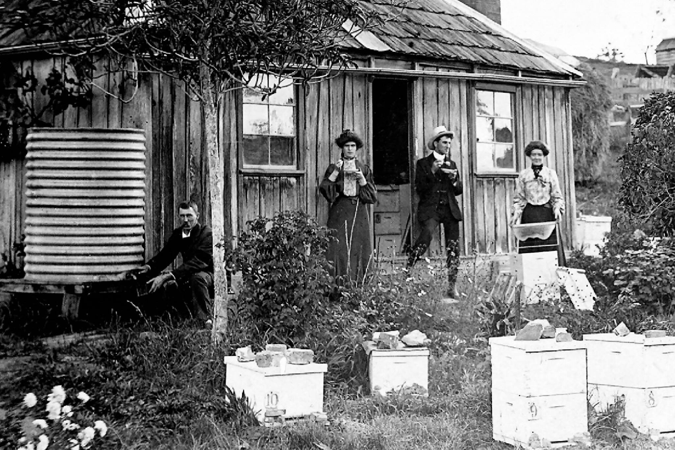
Steven Jacobs‎ Greensborough & Diamond Valley forgotten memories.... what’s your story ?

Sandy Anton this was the Mitchell house
Faye Fort this is my grandfather Will and his two older sisters Prudence and Maria, and we don't know who is the spunky bloke in the middle. A Mr Coghill had the house by this time for his bees he lived in the City that's the rail crossing up to the right

