Briar Hill Bonfire
Matt Craig
Greensborough & Diamond Valley forgotten memories.... what’s your story ?
Community Bonfire between Briar Hill and Diamond Valley Community Hospital.
Does anybody know the history behind all of this? Evidently the local MP, Frank Davis, at the time was involved as was Bob Manuell. They would have a bbq and then a big bonfire. Federal member, Frank Davis carries the torch to light the combined Briar Hill and Diamond Valley Hospital bonfire. Hot oil from the torch ran down the torch and lodged in Frank Davis' sleeve whilst carrying the torch. Bob Manuell advised that as a consequence of this event, every time he met with Frank Davis he was informed that he owed Frank a new shirt. Frank Davis was the Liberal Member for the Deakin electorate 1949-1966.
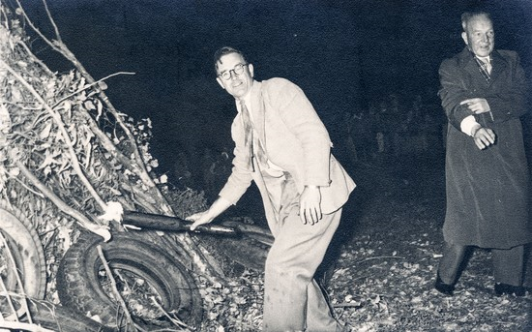
The lighting of the bonfire. Notice the old rubber tyres leaning up against the green waste
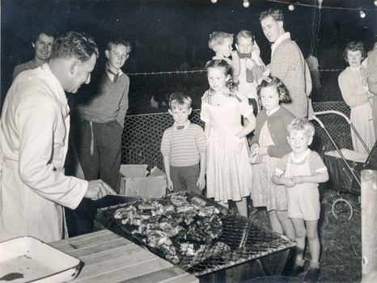
The BBQ

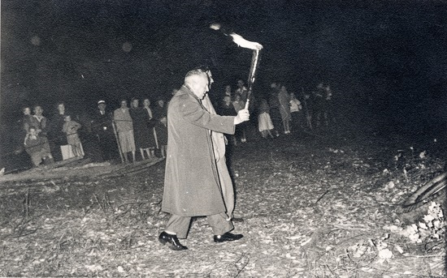
The Ceremonial lighting of the bonfire
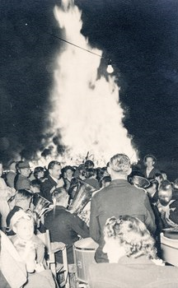
The bonfire in full blaze
Irma Sartori I would like to know when the photos were taken I do remember going to some bonfires but thought they were on the church grounds next to the hospital Mr Brown was the maintenance man and it was he who got the bonfire ready. I also think the photo at the BBQ is me holding Linda and would be 1962 but hard to tell that is not my pram so a date would be good
Matt Craig Irma Sartori, as Frank Davis was MP for the area between 1949 and 1966 it would be within this time frame. So it is more than likely what you have stated that it could well be the year you have mentioned around 1962.
David Collyer Our bonnie was always in the Council Paddock until they were banned. One year David Rooks lit ours a few days early!!!
Sandy Anton Ours was the corner of Nell and Henry St.. it was always huge. .a great night, everyone joining in and having fun
Matt Craig Bonfire night was always a good time when neighbors and children and the whole community in the street or thereabouts had a good time together.
Sylvia Tupper I can remember bonfires being held at Briar Hill school beside the footy oval, then later at the Briar Hill Hall.

