Briar Hill shops 1968
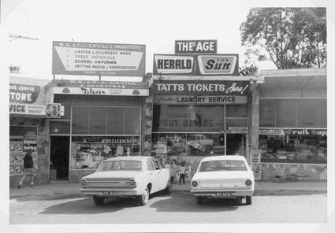
Lyne Clough Walker ‎I GREW UP IN THE GREENSBOROUGH DISTRICT

