Bridge Para Road/Gladstone Road
Sandy Anton ‎I GREW UP IN THE GREENSBOROUGH DISTRICT
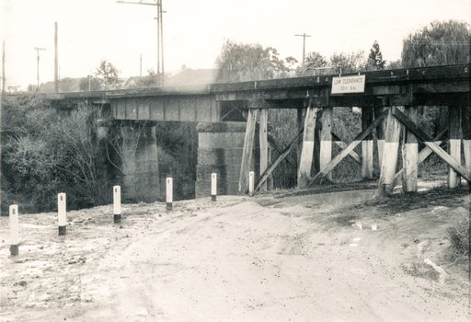

Norm Colvin At least the brick section is still intact. This would be the oldest operating bridge in Greensborough.

