Buttle Family
My name is Patricia Milne Williamson-Wood, my maiden name was Patricia Milne Buttle. Originally I lived in Henry Street Greensborough then in the house built by my grandparents Jane and Samual Buttle on Cnr Warwick Rd and Eldale Avenue.

I understand that my sister has been in touch with your organisation re our family history. Helen White (*nee Buttle) of Gympie Queensland I can provide you with any information that you may require as I am 8 years older than Helen and lived with my grandparents when my mother was confined to hospital with polio.

I saw a photo on your web page Stubley Motors. That business was originally owned by a guy called "Snowy " Jessop. My father worked for him after he left his apprenticeship as a butcher at Willett's.

He later went to work for Russell Manufacturing (Repco Co.) where he stayed until he retired and moved to Madalya near Yarram. He died at age 84 and mother went on to live until 93 years of age.

I am interested in joining your organisation as I may be able to help you with some of the history. My grandparents built there house after the floods in Droop Street Footscray I think somewhere about the 1920-30.

ps my Aunt Ellie Hodkinson, who is 95 lives in a retirement home in Somerville near Frankston went to the primary school and had the same teacher as I did when I went there.

The Hodkinson side of the family originally lived at what was then called Grace Park and I think it was around 1920's

Good evening Noel, Thanks for the prompt reply. Could you send the map at the foot of an email I cannot retrieve as an attachment, please? I know Jean Luxford they were involved with the Anglican Church and moved to Warwick Road almost opposite our house. They lived in the main street for a long time. I thought their father was a minister.
Jean must be in her 90.s by now.

I worked out some dates and my family moved to Greensborough in the early 1920 Buttle side and my mother's side Hodkinson 1921 but they moved to 21 Potter Street Black Rock in the 1940s where they lived until my Uncle died about 4 years ago My Grandfather's brother lived at Briar Hill I think from the early 1920s. My grandfather was a bandsman
on the Cerebus which has almost disappeared in Half Moon Bay (Port Phillip Bay). He was born in Maldon.

My grandmother Jane Whitehead was born in Ballaarat Victoria and her family arrived there in 1854 at the beginning of the Eurecka stockade. Patricia M W Wood

Thanks Noel the aerial map is clear it shows Eldale Avenue and Warwick Road our house was on the right-hand side and Weavers was on the left-hand side, it looks like multiple buildings on our block which was 3 acres as well as Weavers and Mrs and Miss Cox whose block adjourned the new house built by Dr and Mrs Cordner snr when they retired.

Their housekeeper was a Miss Partington (who I think were the first settlers in the district) when aborigines lived there. Miss Partington was a very keen ballroom dancer and she and Mr Stafford would go to the Masonic Hall in Melbourne most Saturday nights. They were in their 60-80s then. But I think they had been doing this most of their lives.

Mr Stafford lived in Warwick Rd near Medhurst's who I think were also related to Partingtons. I believe Faye Partington is a member of your organisation.

We also lived in Henry Street Greensborough until I was about 13 years old. I was born in 1937. We then moved to Warwick Rd as my grandfather had died and my grandmother went to live with her daughter Catie at Footscray.

My parents sold the property when father retired spot on the day he turned 60 as he bought a property at Madalya (near Yarram) and carried out his long lost love of farming.

Another old family were people by the name of Norman's who lived in an old house on the lower side of Warwick Rd. There were 2 boys but I only remember Dick Norman as he was a friend of father's and during the engineers strike (I think it was 1949, as I couldn't go to school, Preston Girls High School for about 6 months, no trains, buses etc) and they went cutting timber at Strathewyn. Later Dick Norman went to work for Bernard O'Reilly Lamington National Park. I think he remained single for a very long time.

Another family that lived in Greensborough were the Maude family. They were poultry farmers and lived in McDowell Street, the same as Trist family who were dairy farmers.

I'm sure you will have documented all this by now. I remember Jean Luxford as extremely nice widely read but not wordly wise (do not repeat). I think I would have given her the horrors with what I got up to.

Bought my own car at 19, rowed for Essenden Ladies Rowing Club (when we weren't allowed to row on the Yarra) etc etc....!!!!

Thanks for the map in particular the aerial one.
PS another old family was the Coe family who lived in Alexander Rd. a big block opposite Greens'

Best wishes I had better go and do some work instead of telling you
info that you probably already know Pat W

From Facebook
Helen Buttle’s house was known as Montrose was on 2 1/2 acres at the top of Eldale Ave at the end of The lane known as pine tree alley on the corner of Warwick Rd. It was demolished in the 70s. Thanks to Helen White.. GHS can share WITH HER PERMISSION.. They came from Montrose in Scotland hence the name of the house.
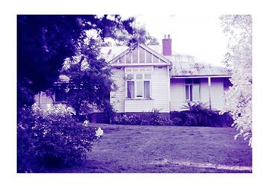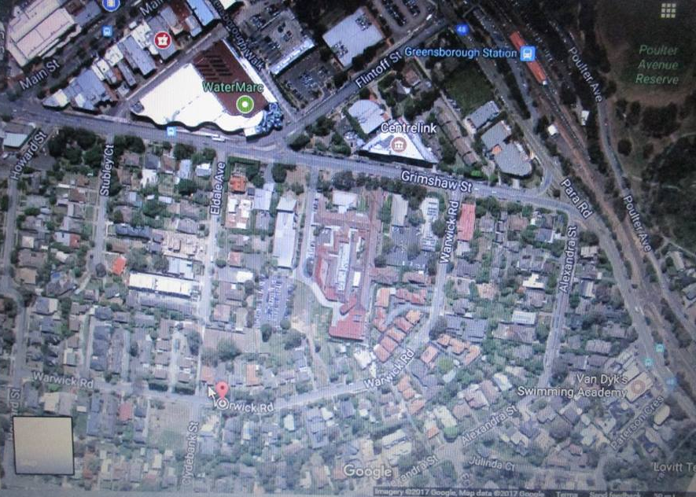

Helen White Faye we lived in Henry St, next door to Mrs Jones she was a great friend of the family. The house in Henry St was still there when I last visited Greensborough a few years ago. My mother wore an iron caliper on her left leg. Mum got polio during the epidemic in the 1930 s. Mum was an amazing woman despite her disability, she died at the age of 94. My father did knit, I can only remember him knitting socks, but his sister Katie did a lot of fancy knitting. He died suddenly at 84.

Faye Fort Helen White thank you so much for telling us your history It was quite unreal. Your lovely mum Having had polio then about 1949 Ron Jones your neighbour also catching the dreaded polio also Ron passed away a few years ago But it never stopped him from doing what he loved to do but sadly he really was getting worse through his disabilities It was a dreadful thing at the time one of the Burra kids being so sick His brother Alan has passed on also Ron Ian Foard and my brother Trevor all had their 18th birthdays in our barn in Hailes St ( now Whatmough Park ) What great times they were back then

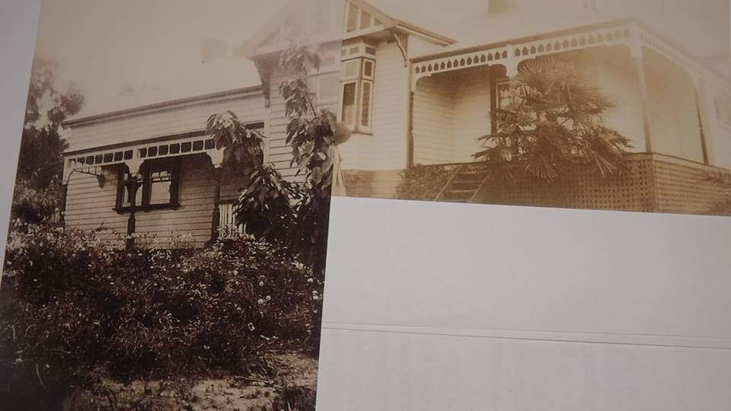
Helen White I have found 2 photos of my home in Warwick Rd . These are of "Montrose" in her earlier years. I have tried to pair the 2 photos together as best I can, it gives you an Idea of the size of the home and the beauty of it in my opinion. The far left is the Dining Room and the far right is what was Pat's bedroom which became mine after Pat left home. The large Lounge room is in between these two rooms with a hallway between the lounge and dining room. The hallway opens out onto the first small balcony. Which had steps up to the front door. On the far right side turn left at the end of the veranda, and go down to a door which open into one of the bathrooms The main bedroom was next to the bathroom, it extended part the way up the other side, with two more bedrooms along that other side of the house. The backdoor entrance opened into a hallway, on entering the house the bathroom was on the left then the Kitchen which opened into the dining room through a single door. There was a wide hallway down the centre of the house that my mother used to polish, I have very fond memories

Sandy Anton it was beautiful...l remember all the gateways in the lane to these houses that backed onto pine tree alley

Helen White Sandy thanks for your help with posting this. I never knew they named the Lane way Pine Tree Alley, it was a dirt road with lots of gutters in it. when I was there . I remember Pat coming home late one evening and there were no lights in the lane way in those days and there was a gutter near our back gate. Pat stepped over the gutter, only to find a man lying in it. She got a fright and ran inside., my father was still up reading he had not long been home from work. As he approached the lane way both his lights went out and as he got near the gate he felt a bump, but did not worry. Until he realised what had happened. Fortunately, the man was not hurt. He was so full of beer he did not feel a thing, our car was a Humber Super Snipe a very heavy car
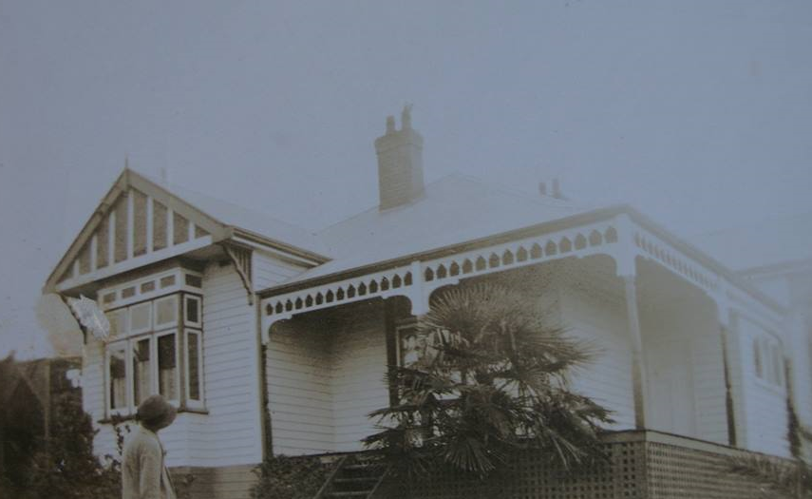
Helen White: I do not want to bore you about my home " Montrose" but today I found a photo of the Original house before the extension, that is Nanna Buttle in the Garden. I will have to find out what year the big flood of the Maribyrnong River was which flooded Droop St., Footscray as that was their previous address. Please would anybody on this sight know?
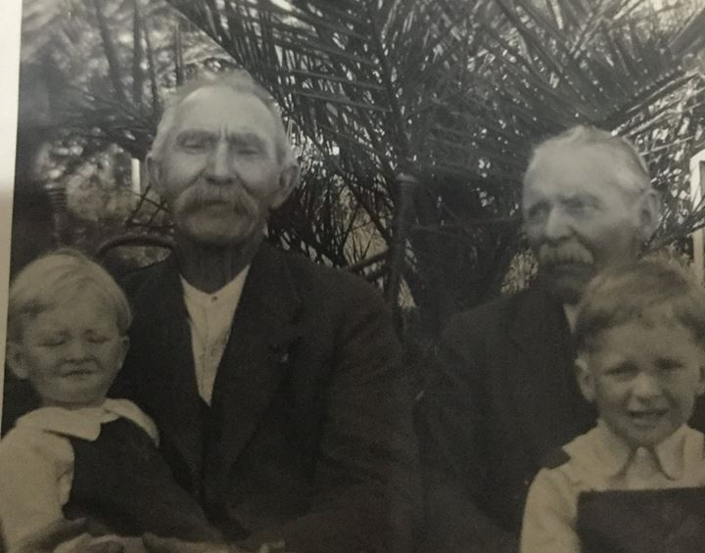
Helen White‎ Greensborough & Diamond Valley forgotten memories.... what’s your story ?

A family photo of on the left is Great Uncle Bill Buttle He lived at Briar Hill, he never married. On the right is my Grandfather Buttle. The two children are my cousins Bill and Jim ,my Dads sisters children . Grandfather Buttle was born 29th October 1869, Fryerstown, Victoria. He married Jane Elizabeth Whitehead on 4th of June 1904. My Grandfather was a Woodcutter, Stonemason, Railway Fettler, Bridge building Clerk, Head clerk in inspector of Ironwork and Bridges Department. Rifle shooting World Record Holder. Bandsman in Victorian Naval Reserve he played the Tenor Horn which is still in the family today. He lived at "Montrose” Warwick Rd., Greensborough a lovely man.

