Carnon Street Greenhills
Jessie Partington’s house

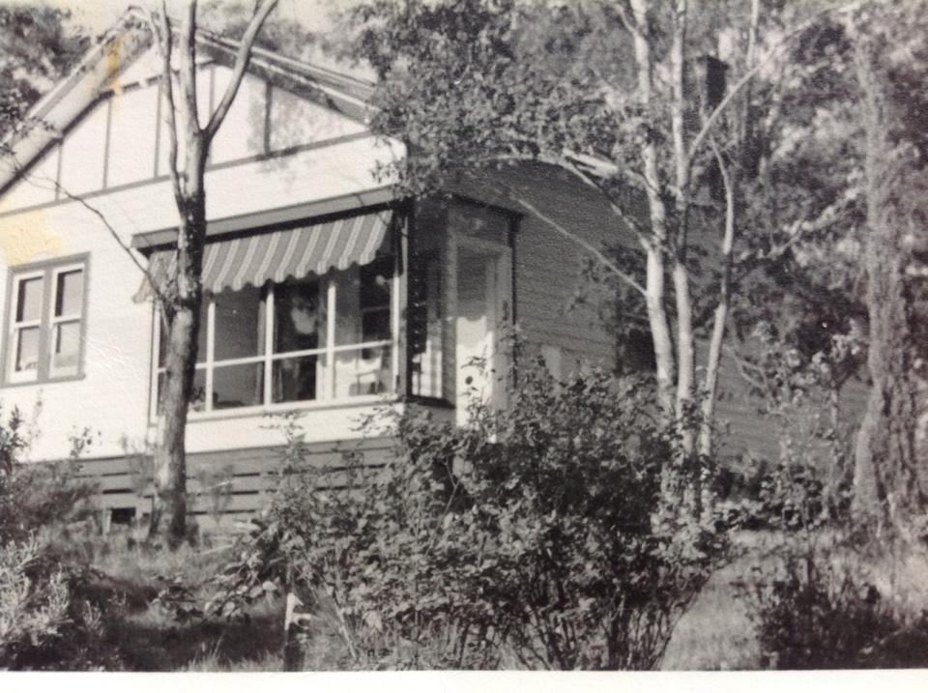
Faye Fort‎
Greensborough & Diamond Valley forgotten memories.... what’s your story?

