Eltham High
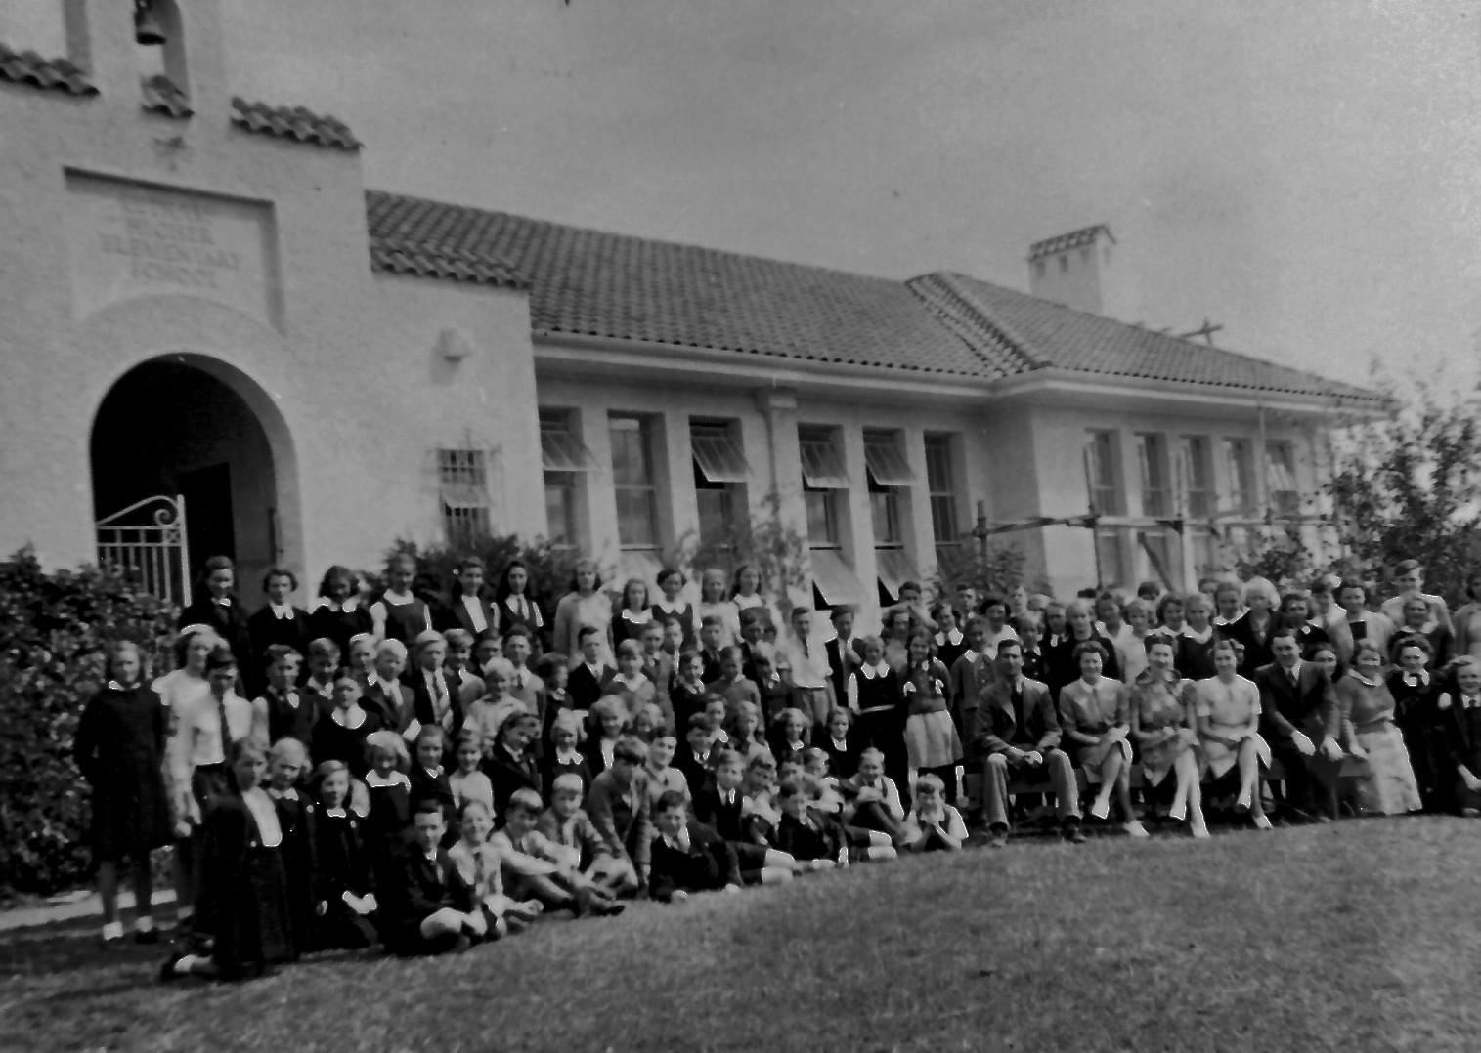

Lyne Clough Walker‎I GREW UP IN THE GREENSBOROUGH DISTRICT

Who went here and in which years? Photo is of Eltham Higher Elementary School in 1944, later to become Eltham High School.

