Greensborough August 1958
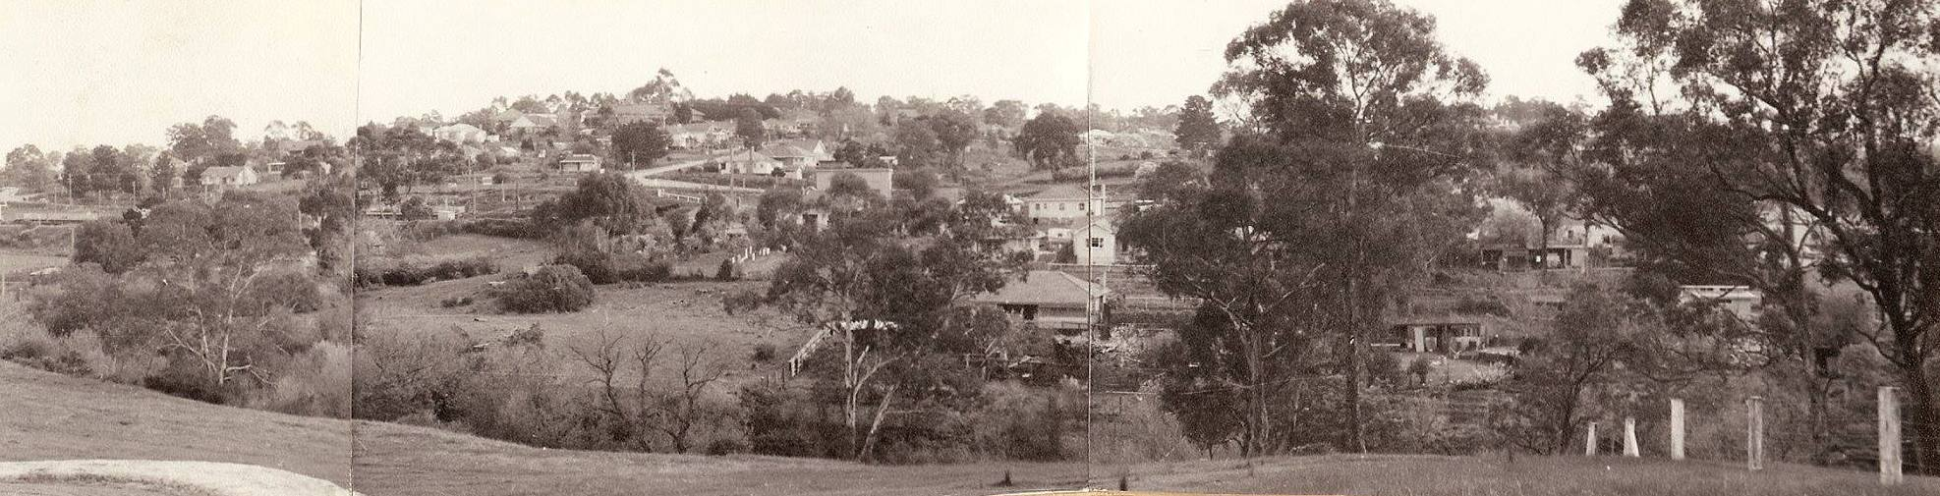
Panorama - Courtesy Jan Lewis
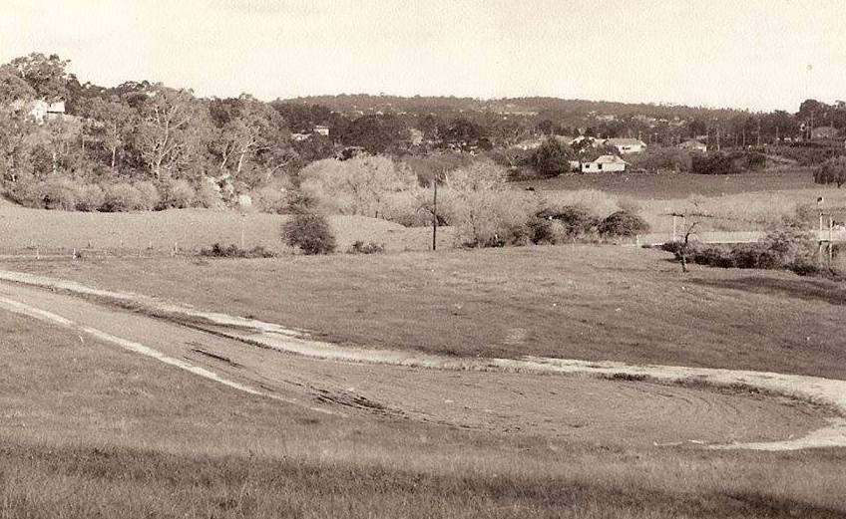
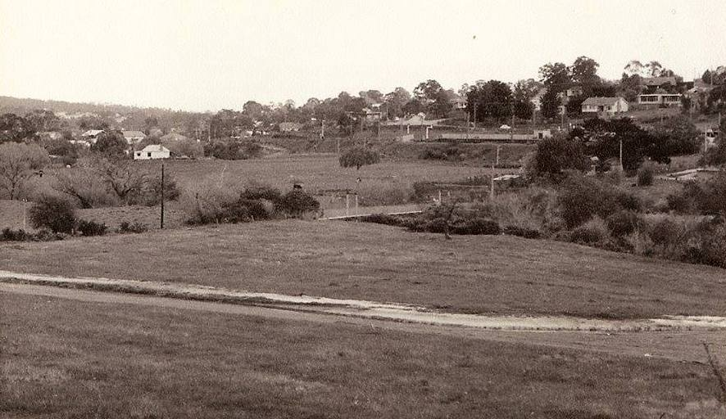
blick das tal entlang – “View along the Valley” (Greenmeyer Court)
Photos courtesy Jan Lewis
Lyne Clough Walker‎ Greensborough & Diamond Valley forgotten memories.... what’s your story ?

