Greensborough Hill Climb

Sandy Anton
Greensborough & Diamond Valley forgotten memories.... what’s your story?

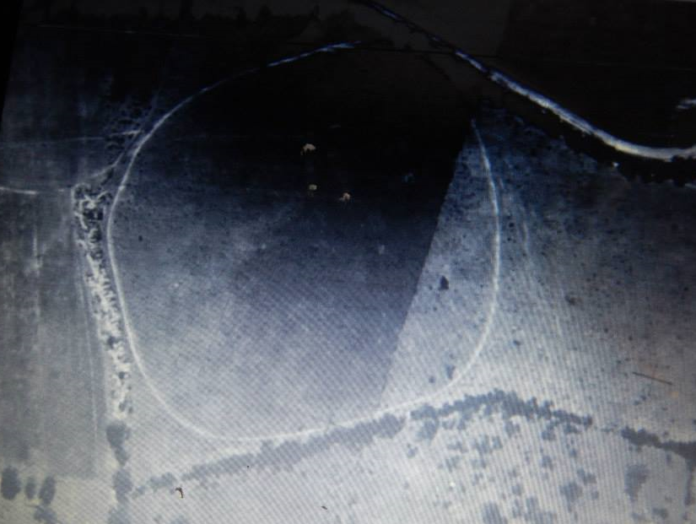
1945 aerial
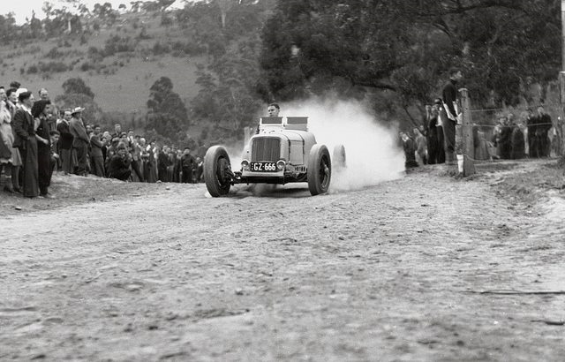
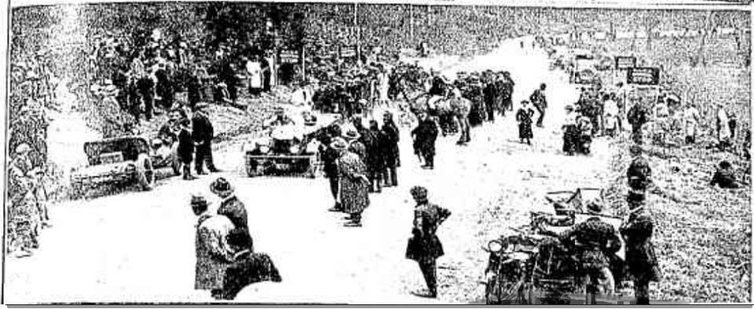
Jan Muller - 1923 Greensborough Hill Climb, Diamond Creek Road
Debra Bruning Football oval??? Where is it
Sandy Anton No not football oval..its from the 1945 map. That’s the aqueduct behind it...it’s back in the paddocks almost directly opposite Loyola
Sandy Anton it’s a complete circle
Faye Fort It belonged to the Haliburtons up at Point Look out Plenty
Faye Fort You know those photos you found of that hill climb and we didn't know where it was Sandy. Well this is the race track Mr Haliburton made for it. You can look it up
Sandy Anton Oh wow this is where the hill climb was...very steep in the photos
Faye Fort Yes well it was very steep near where the children's cemetery is Sandy
Sandy Anton Added a hill climb photo. Will see if l can find the cemetery
Sandy Anton l love that map :)

Sandy Anton l found where the aqueduct crossed the river...but it’s not very clear

Faye Fort The Haliburtons bought the old Adam Bosch house Their kids used to walk from there to Greensborough State School
Faye Fort This is where my G Grandparents Ellen and Charles lived and had the 5 boys they moved here with the two girls when he moved from the Toll gate cottage in Grimshaw St Watsonia

