Greensborough Post Office

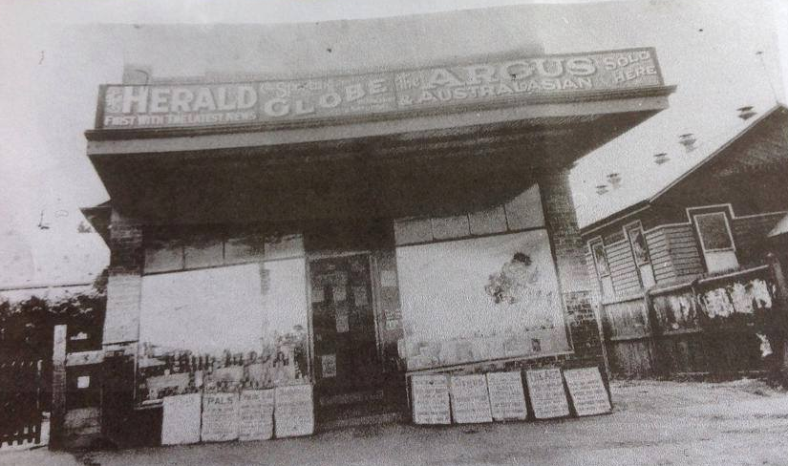

Greensborough & Diamond Valley forgotten memories.... what’s your story ?
Sandy Anton it was our post office with Mr Cecil running it. l remember climbing those stairs as a kid, they seemed so big. The lane was next door, then the pictures. The hall you can see had a new front put on it, and it became Ashril
Lynette Clark Wow that was before our time. Mum and dad would have loved to see this photo. Dad shared with the Post Office at first till it moved across the road and reopened as just the PO.

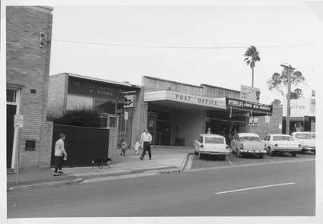
Dean Gale Look how small the bank is, Which bank was that? I remember going inside as a kid at primary school was like a big day out, on the bus to Burra.
Sandy Anton State savings bank. Next to PO

