Greensborough Primary Circa 1900

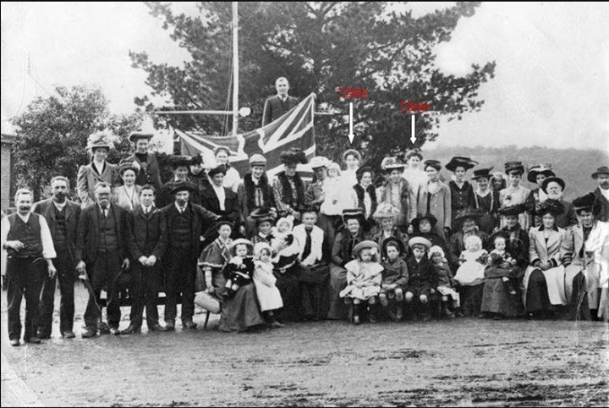
David Shane Amiet‎ Greensborough & Diamond Valley forgotten memories.... what’s your story ?
My cousin and I think the 2 ladies indicated may be Elsie Amiet (Headmaster Louis Amiet's sister) and Rose Lillian Mitchell nee Amiet.

