Greensborough Primary School
Alma Quon and the school ball
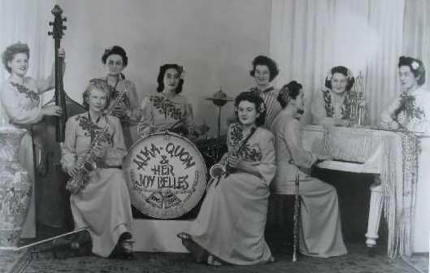

Greensborough & Diamond Valley forgotten memories.... what’s your story?
Sandy Anton Remember we would walk to the football ground hall in grades and practice for weeks before. Miss Quon giving orders and another lady on piano. She knew how to control kids that’s for sure.
The day of the ball we went to school. Buses took us down to Heidelberg Town Hall. We had a practice run then come home and got ready
Some had their hair in rollers some in rags at the practice
Then the night of the ball our parents dropped us down stairs
Miss Quon was on that stage with her band and she controlled us from there...it was wonderful...the whole school
Paul de Sauty I remember those days. She pointed her finger at me once whilst giving me a dressing down for not taking the right step at a crucial time.

