Greensborough Station 1967

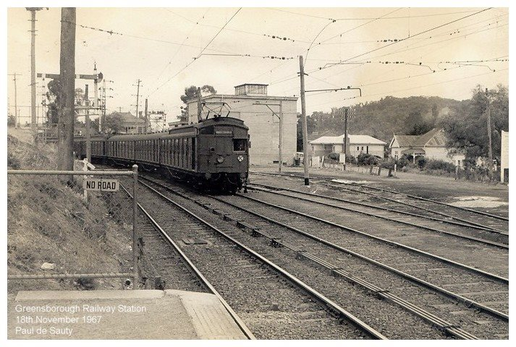
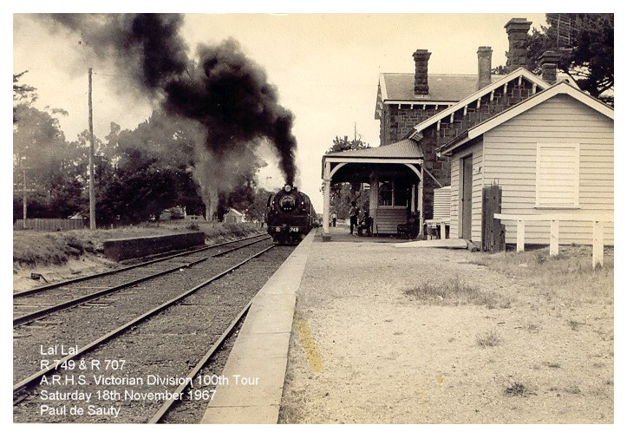
Paul de Sauty ‎I GREW UP IN THE GREENSBOROUGH DISTRICT
In this view of Greensborough Railway Station, we see a Down Hurstbridge bound "Tait" train (quite rare at that time; was usually a doggie) entering No.2 road in order to cross an Up Hurstbridge train bound for Princes Bridge. The former goods siding and sub-station can be seen in the background. This safe working manoeuvre was eliminated when the station became an island platform. The time and date was 5.30am Saturday 18th November 1967. Ian Kemp and I were heading to Spencer Street Station to catch a special steam train excursion to St. Arnaud and return. (The second photo is included to illustrate the tour we were on that day).

