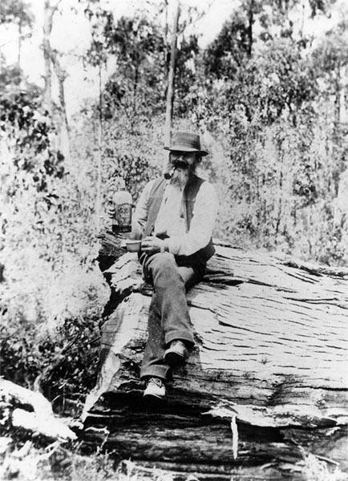
John Lee GRIMSHAW

Pam Ippolito‎ Greensborough & Diamond Valley forgotten memories.... what’s your story?

This is John Lee Grimshaw - the only photo I have of any of them - found on Trove. He was the first person to find gold at Kinglake.

Pam Ippolito He seems to have lived in Kinglake, see obituary....so not sure if it is him. I know that the younger sons, William and Samuel lived around Whittlesea too.
Pam Ippolito [His father was] Aaron, he was the eldest son.

Obituary – John Lee Grimshaw
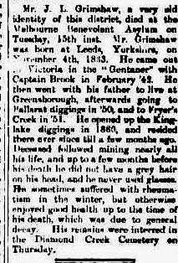

Pam Ippolito ‎Greensborough & Diamond Valley forgotten memories.... what’s your story?
John Lee Grimshaw's obituary from the Eltham and Whittlesea Shires Advertiser and Diamond Creek Valley Advocate Friday 18 October 1918. (TROVE)

Aaron GRIMSHAW
Pam Ippolito Greensborough & Diamond valley forgotten memories.... whats your story ?
I have a copy of Aaron's will dated 5th July 1890. (Transcription):
This is the last Will and Testament of me - Aaron Grimshaw of Hazeglen, in the county of Evelyn, colony of Victoria.
After payment of all my just debts funeral and testamentary expenses, I give devise and bequeth unto my wife Rebecca Grimshaw if she survives me the interest of my property for her life and at her death one hundred pounds to equally divided amongst the children of Henry Dosser deceased viz Mary Louisa Thomas, Emily Fouracre, Reuben Hedley Dosser, Elizabeth Jane Dosser and Ellen Maria Dosser. The balance of my property to be equally divided between the daughters of my son John Lee Grimshaw viz Mary Elizabeth Grimshaw and Annie Rebecca Grimshaw.
And I hereby appoint Thomas Harmer JP framer of Bundoora and Joseph Verso musician, of Northcote executors of this my will. In witness whereof I have hereunto set my hand this 5th day of July in the year of our Lord One thousand eight hundred and Ninety.
Signed by the said Aaron Grimshaw the testator and by him declared to be his last will and testament in the presence of us present at the same time who in his presence at his request and in the presence of each other have hereunto subscribe our names as witnesses.
Signed
James Reid (his son-in-law) and James Lowe (Wesleyan Minister, Preston - however when probate was granted in 1893, his present address was unknown)
Probate was granted on 27th Sept, 1893.
Inventory stated he owned no real estate.
His personal estate was 450 pounds in the trustees of the Wesleyan Church, Preston and furniture valued at 5 pounds and clothing valued at 1 pound - a total of 456 pounds.
From this I can ascertain that Aaron wished to help some of his grandchildren, especially the children of his daughter Anna Eliza and her husband Henry Dosser, who had both died 10 years or so previously. The children ranged in ages from 15 to 25 at the time of the will - 1890, and obviously had been orphaned at a young age.
The other two grandchildren mentioned are the two daughters of John Lee - They were aged about 20 and 9 at the time. Their mother had died when the youngest was a baby in 1881, so this may be why he wished to look after them in the will. There was no mention of the boys from this family though, so perhaps he felt more for the girls being left without their mother. Nothing was to be left to any of the other grandchildren, but their parents were all alive at the time, so I believe that this was his motivation at the time.
His wife Rebecca was still alive, but I have not found a will for her from after her death in 1898, so I do not know if his wishes were granted to these grandchildren or not.

