**Hurstbridge Rail Line 1967**

[**Paul de Sauty**](https://www.facebook.com/paul.desauty?fref=nf) **I Grew up in the Greensborough District**

On Saturday 26th August 1967, the Victorian Division of the Australian Railway Historical Society ran a "Mystery" Tour" around the suburbs of Melbourne. Part of this tour included a run out to Hurstbridge. These photographs are a record of the tour between Greensborough and Hurstbridge.

[[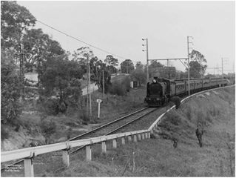](https://www.facebook.com/photo.php?fbid=562674587255632&set=pcb.971513166309849&type=3)](https://www.facebook.com/photo.php?fbid=562674587255632&set=pcb.971513166309849&type=3)

Greensborough, opposite the [Cemetery, near Marsh property.](https://www.facebook.com/photo.php?fbid=562674577255633&set=pcb.971513166309849&type=3)

[[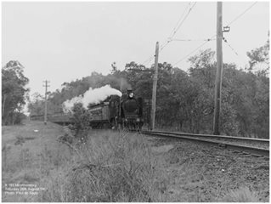](https://www.facebook.com/photo.php?fbid=562674577255633&set=pcb.971513166309849&type=3)](https://www.facebook.com/photo.php?fbid=562674577255633&set=pcb.971513166309849&type=3)

[[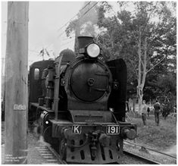](https://www.facebook.com/photo.php?fbid=562674590588965&set=pcb.971513166309849&type=3)](https://www.facebook.com/photo.php?fbid=562674590588965&set=pcb.971513166309849&type=3)

