Hutchinson caravan ‘dolly’
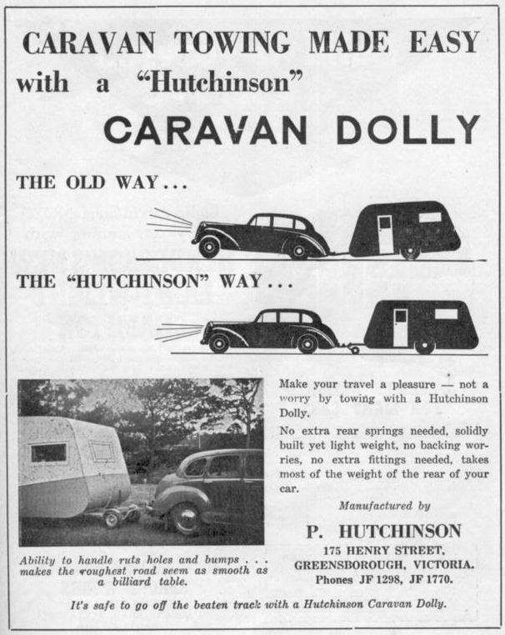
Marilyn Smith‎ Greensborough & Diamond Valley forgotten memories.... what’s your story?

Faye Fort Went to Greensborough state school with Gordon and Joyce Hutchinson of Henry St
Matt Craig Went to church with Old Bill Hutch and Grace Hutchinson, young Billy Hutchinson and Terry Hutchinson and all the brothers and sisters. Seems like yonks ago!
Sandy Anton They lived around the corner from us. I remember their dolly wheel..Dad always pointed them out when we were on holidays..it was amazing how many there were..they were very popular

Faye Fort When Gordon left Burra school he went to Swinburne Tech which was a big thing for a Burra boy back then

