Hutchinson Family
Matt Craig‎ FACEBOOK
Greensborough & Diamond Valley forgotten memories.... what’s your story?
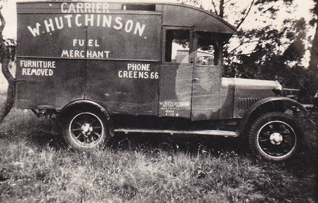
Here's a goody for you all. Evidently the first vehicle that Old Bill Hutchinson used for transporting furniture around the district. He must have started off with this little beauty and then progressed further until such time he had a fleet of trucks and had the Soil and Gravel Supplies in Para Road.
Sylvia Tupper Reminds me of the furniture trucks they used to hire to transport us on Sunday school picnics. Put in some church pews as seating and fill with as many as would fit. Imagine that nowadays! No seat belts.

Matt Craig
The name Hutchinson may ring a bell with many of you particularly going back to the 30s and up to the 70s. Old Bill Hutchinson owned the Soil and Gravel Yard on Para Road. He and his wife Grace resided in Rattray Road for many years as I can recall going there each Christmas with the Church I attended as did the Hutchinson's to sing Christmas Carols on the Eve of Christmas. There were a few Hutchinson's around at the time, young Billy Hutchinson who I believe resides somewhere up in Greensborough. Terry Hutchinson ran and owned the Engineering workshops also on Para Road where he did some modifications to a car of mine many years ago.
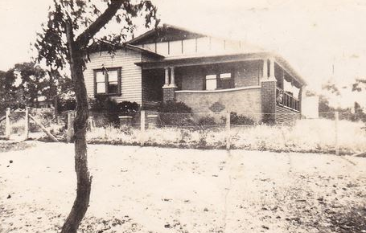
The Hutchinson residence in Rattray Road.

Hutchinson's Soil and Gravel Supplies, Para Road.
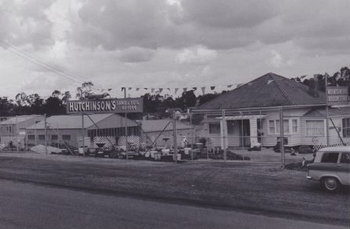
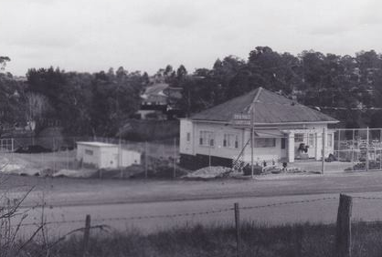
Adrian Redfern Terry lives and still operates engineering in Doreen.
Sandy Anton One family lived in Henry St
Ross Brooks Ruth was a Sunday school teacher and Borden was a teacher at Watsonia tech
Matt Craig Ross Brooks, are we talking about the same Hutchinson family?
Sylvia Tupper Another member of the Hutchinson clan lived in Sherbourne Road, just down the hill from Mountain View Road on the Eltham side. Their daughter Beverley attended Briar Hill State School.
Matt Craig Bev lives in Bundoora
Jo Petrovic Thanks for the memories Matt. I seem to remember a Bill and Betty Hutchinson (I think they were) who had two daughters Val and Mavis. Then another family who had a daughter Joan. I do remember Terry as well.
Bev Burgoyne There were two families in Henry Street.
I think the families were all brothers
Bev Burgoyne Mavis and Joan were sisters
Jo Petrovic Thanks! I was only 10 when we left the district. Fond, but rather fuzzy memories!
Bev Burgoyne Terry was their brother

