Jacobs Family - 25 Scotland Avenue Greensborough
Photos from Steven Jacobs‎ Greensborough & Diamond Valley forgotten memories.... what’s your story?
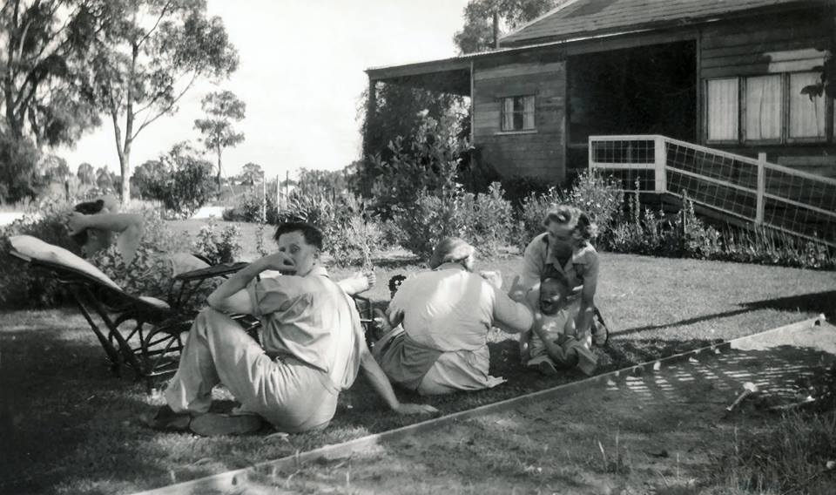

A couple of others that were also taken at the Scotland Ave property - Fred and Elsie Roberts on the left and the whole family on the right. [below]

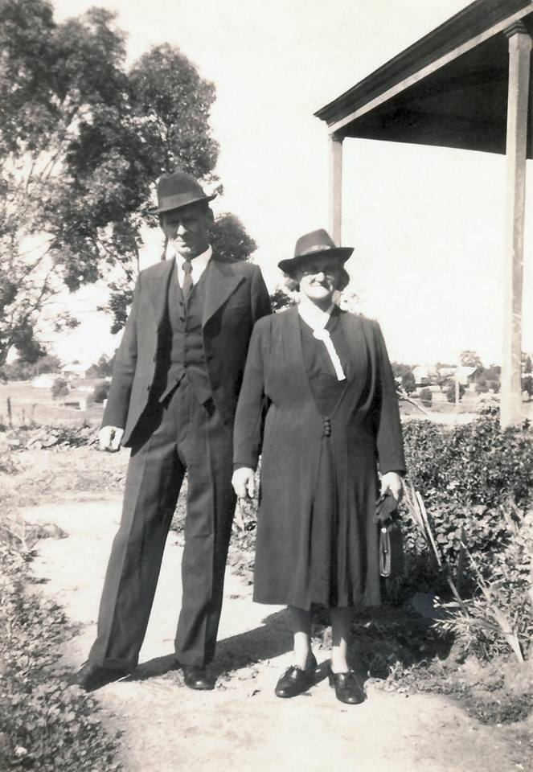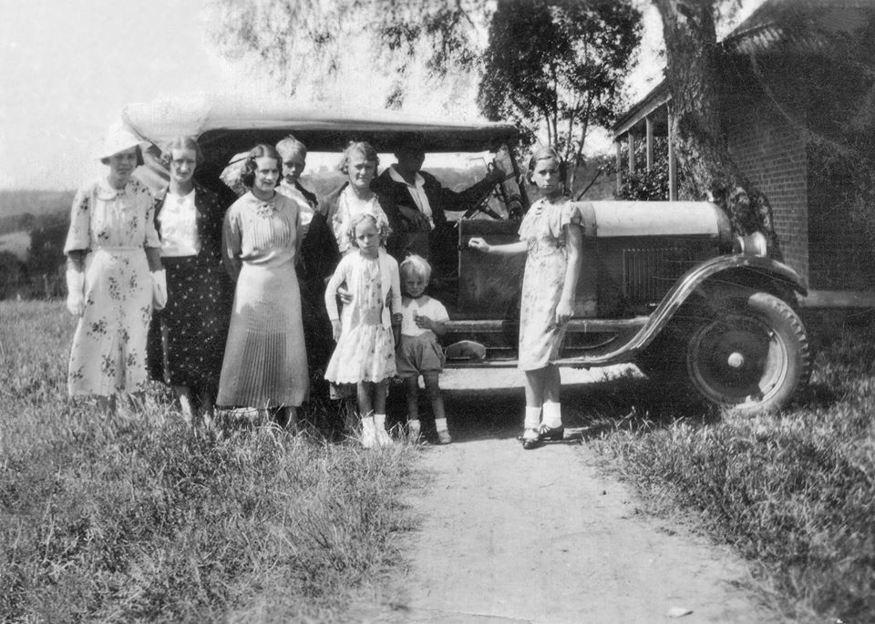
Steven Jacobs I wonder when Scotland Avenue and Mayfield Street were officially named given neither of them appear to exist in the 1945 aerial photo of Greensborough.
My mum, Evelyn Roberts, sitting on the porch at the Scotland Ave house around 1939/40. My Mum has always maintained that the family moved from William Street to the Scotland Ave house when she was about 12 years old, so somewhere around 1935
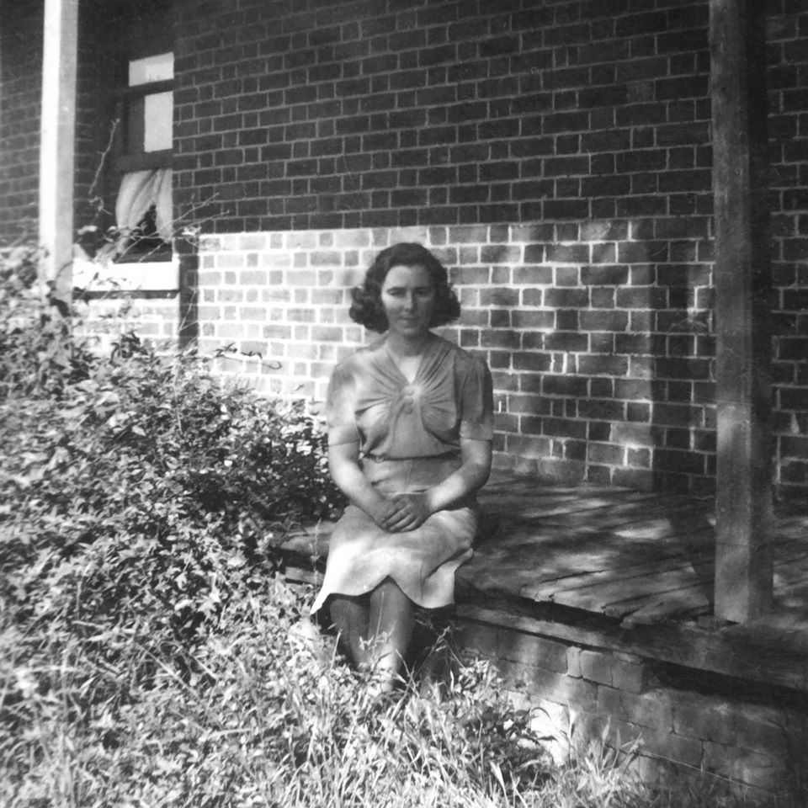
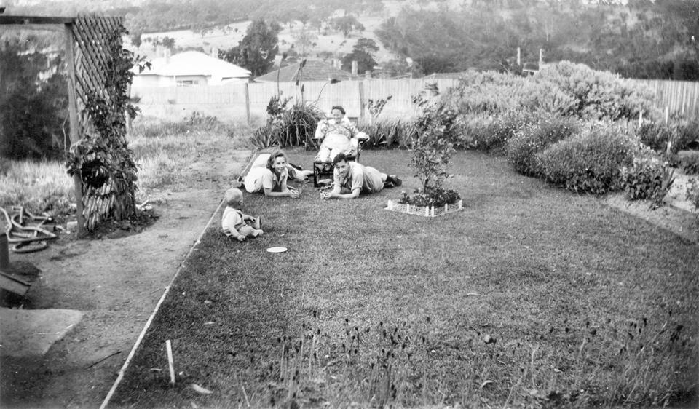
From left to right: my eldest brother Rodney, my mum Evelyn Jacobs (Roberts), May Anderson (Causer) and her husband Ernest Anderson. My grandmother Elsie Roberts (Causer) is also in the photo but is hidden behind my mum. Over the back fence you can see houses in Hailes Street, a railway line staunchion and in the background, land that is now occupied by Apollo Parkways.

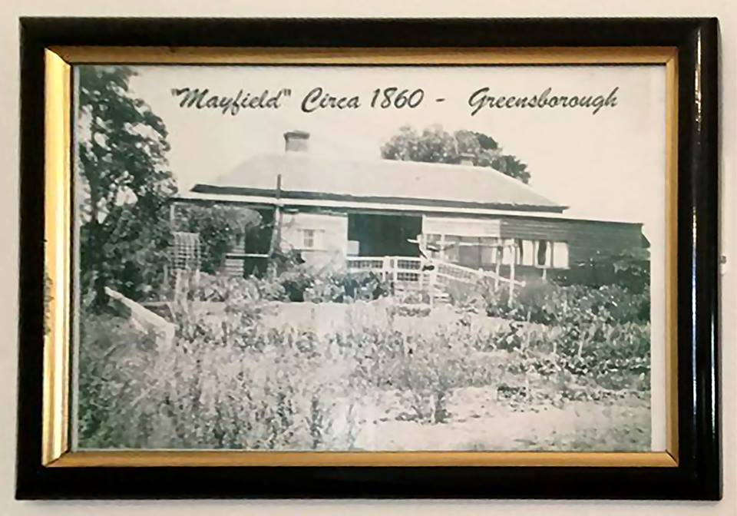
Sandy Anton So now we have worked out that your Grandparents house was the Scotlands house called Mayfield and that’s where the 2 street names came from
Steven Jacobs We certainly have Sandy - my next task is to see if any records exist re sale to my Grandparents.
Steven Jacobs Thank you Faye for taking this photo during your visit. I'm a bit surprised that I can't recall any of my aunts who spent time living in the house ever referring to it as 'Mayfield'.
Sandy Anton Maybe they didn’t call it that Steven. Maybe only the Scotlands used the name. It would be a bit silly having a house in Scotland Ave called Mayfield with Mayfield Street so close. The poor postie would get confused
Faye Fort Steven seeing Jessie Scotland passed away in 1924 Age 95 John passed 1888 age 65 Perhaps Jessie was still living there in 1924 and your grandparents bought the house when she passed?
Sandy Anton That would make sense Faye. They would have been about the right age to buy a house. Mr Roberts was a lot older than my Dad when we went to their house
Faye Fort Funny that it's taken so long for us to work that out. Bill Cecil would have delivered mail to them. Just to ask was it Mayfield back then

