Main Street Bluestone bridge
Sandy Anton FACEBOOK
‎Greensborough & Diamond Valley forgotten memories.... what’s your story?
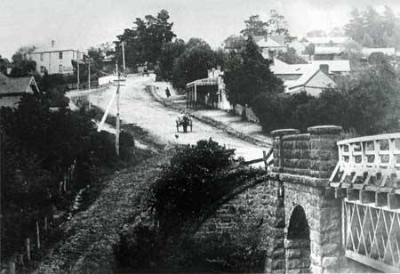
Sandy Anton The rail bridge is there..so l wonder what year it was taken ?

Sandy Anton look how bushy it was up Main St

Terry Leaford Double storey house corner Carter St and Main St picket fence over rail way line below fence is Poulter Ave house on left could Mr Edwards house on corner of Joyce Ave

Sandy Anton l don’t think the new hotel is there...love the little dog following the cart

Dean Gale Horse and cart, trees in Main St got to be 30s ?

Sandy Anton l think the new hotel was built in 29 so before then

Sandy Anton 1925 it was built

Dean Gale I was trying to remember that somehow 35 I thought the pub was rebuilt.

Sandy Anton 1902 they got the rail. So it’s between 1902 and 1925

