Methodist Church Hall

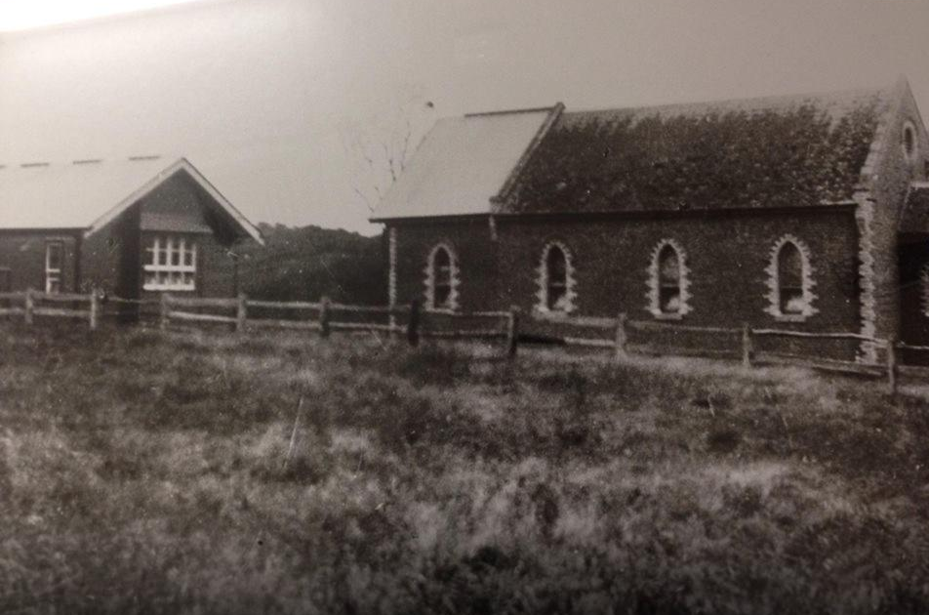

Faye Fort‎ Greensborough & Diamond Valley forgotten memories.... what’s your story ?

Methodist Church Hall. At the back where the ladies later held their meetings
The ladies guild was founded in 1925 the proceeds of their work were used for a vestry built on the back of the church for 300 pounds, a kindergarten in the back hall for 500 pounds was in 1930. It also contributed to their trust fund. In 1907 a branch of women's auxiliary for overseas missions was established. In 1964 G J Coles paid 64 thousand for the old church in Main St
The hill around Partingtons Flat in the background

