Methodist Church Ladies Guild
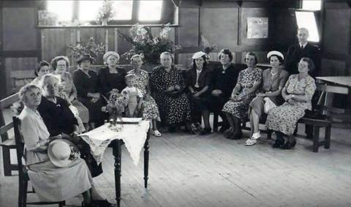
Faye Fort Ladies Guild at the Methodist Hall which started in 1925 Annie Partington was president for over 40 years
Sandy Anton All beautiful ladies...yep that’s where we had guides
Faye Fort Mrs Weaver. Annie Partington. ? Linda Jones with little Ron ? Mrs Roberts, Ollie Laing with little Robert, Amy Knapsey, Mrs Hall ? Mrs Berryman, Nell French, Mrs Hall ( I think right Steven )
Sandy Anton No ..Florence Berryball Faye

Sandy Anton l wonder if that’s Mr French, can’t remember what he looked like but he is standing behind Mrs French. Someone from Williams St should know

